Default values when you input the From and To dates which is ok

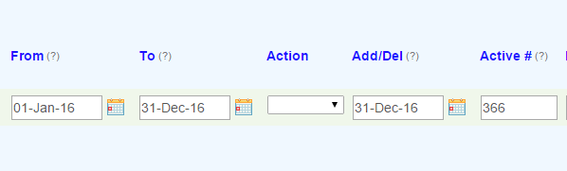

Outcome after you change the Add/Del date which is ok



Outcome when you add a second row and inoout the From and To fields. Note the change in the ADD/DEL and Active# fiedd of the first row

