I have following field in my template

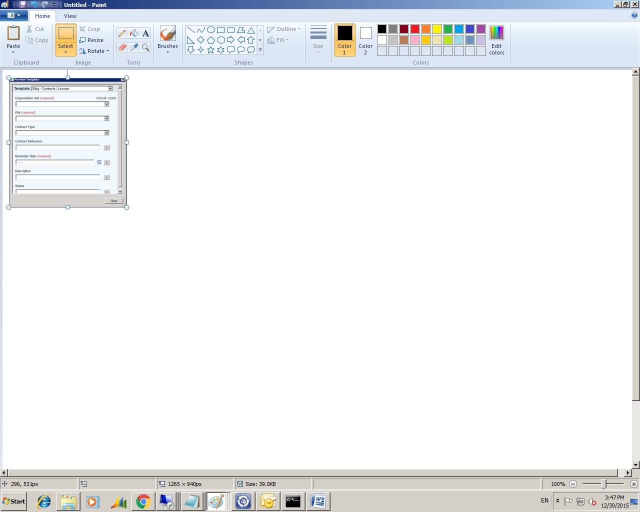

When the user entries reminder date on the above field

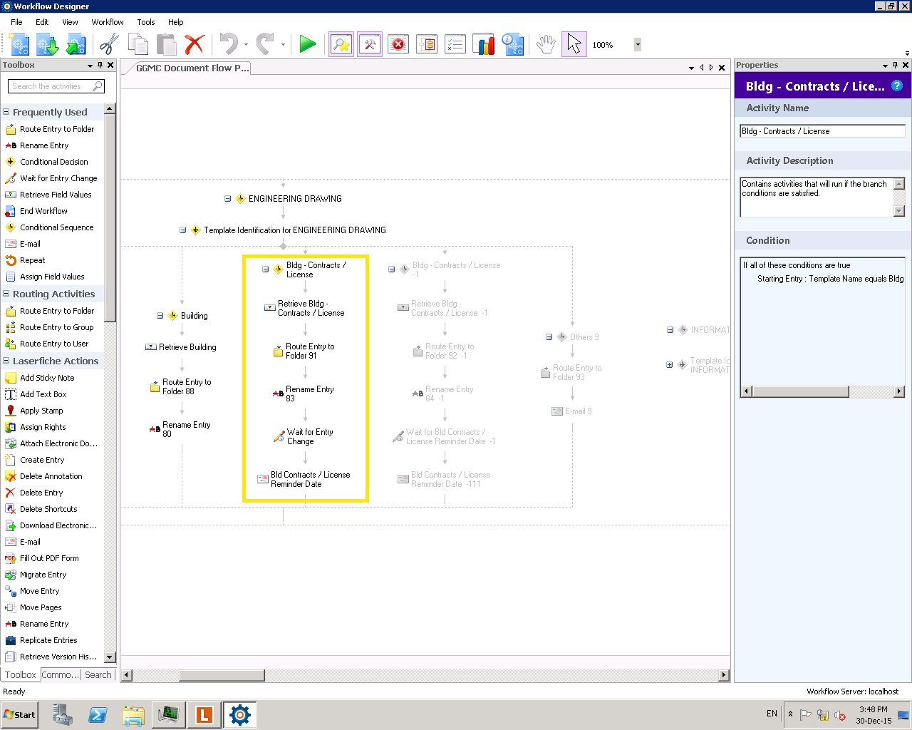

The below is condition on wait for entry change

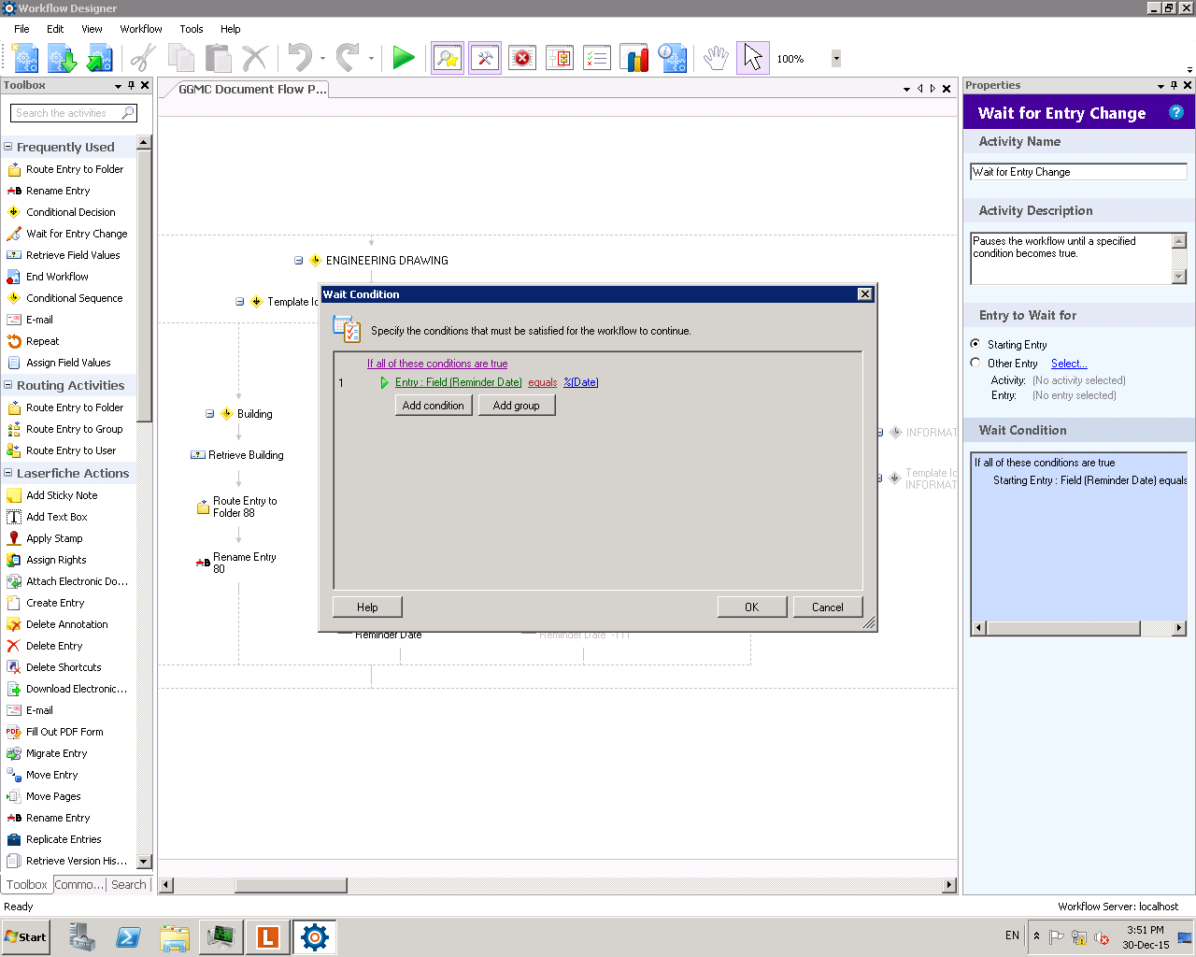

**The condition entry was deleted.[XXX\shibuk] [0650-WF0]**