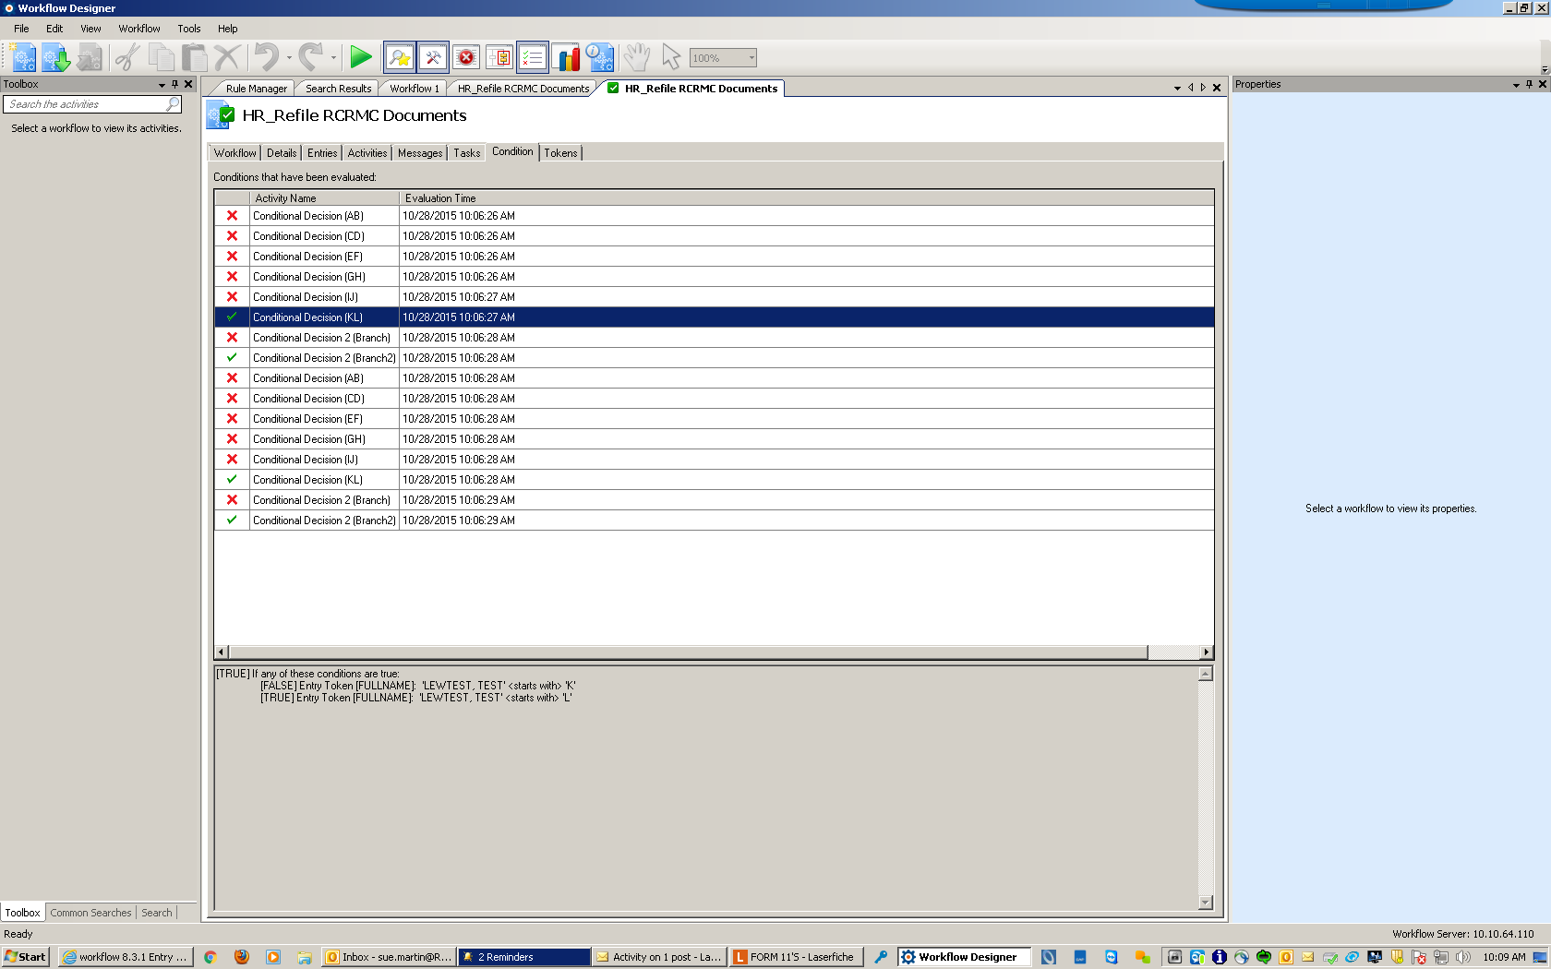

**First Check:**

[TRUE] If any of these conditions are true:

[FALSE] Entry Token [FULLNAME]: 'LEWTEST, TEST' <starts with> 'K'

[TRUE] Entry Token [FULLNAME]: 'LEWTEST, TEST' <starts with> 'L'

**2nd Check:**

[TRUE] If all of these conditions are true:

[TRUE] Folder Folder Count: '0' <is less than> '1'

**3rd Check:**

[TRUE] If any of these conditions are true:

[FALSE] Entry Token [FULLNAME]: 'LEWTEST, TEST' <starts with> 'K'

[TRUE] Entry Token [FULLNAME]: 'LEWTEST, TEST' <starts with> 'L'

**4th Check:**

[TRUE] If all of these conditions are true:

[TRUE] Folder Folder Count: '0' <is less than> '1'