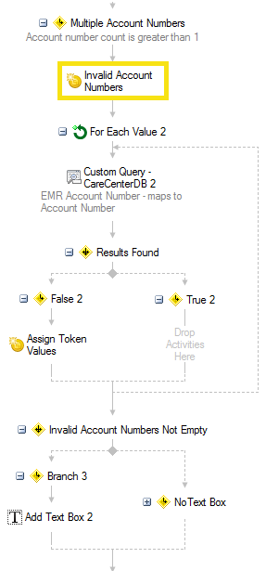

**Invalid Account Numbers Not Empty**

If there are values in the “Invalid Account Numbers” Token, a Text Box will be added

If there are no values, all account numbers were valid

**For each value** – Retrieve Field Values – All Account Numbers

**Custom Query** – For Each Value – Current Entry

**Results Found** – True/False

**False**

“Modify” Token Value for Invalid Account Numbers – APPEND to existing values

**True**

No conditions

New “blank token value” for Invalid Account Numbers (I got hung up on the “blank”

Token above that counts the number of account numbers (>1 for this branch)