In an effort to clean things up a bit☺

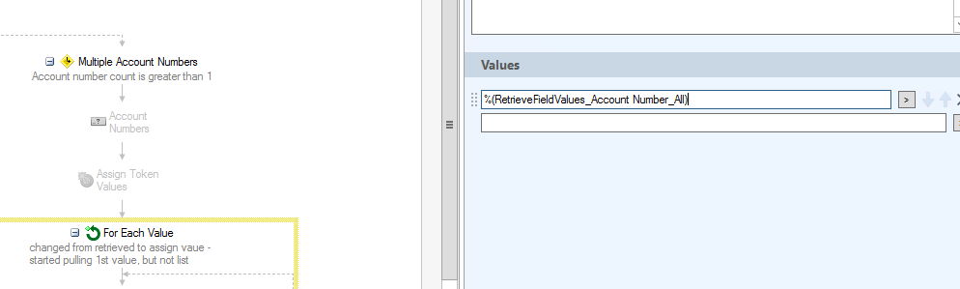

Disabled because I’m retrieving values at start of WF

