This is my main workflow A which is routing shortcut of document to respective users.

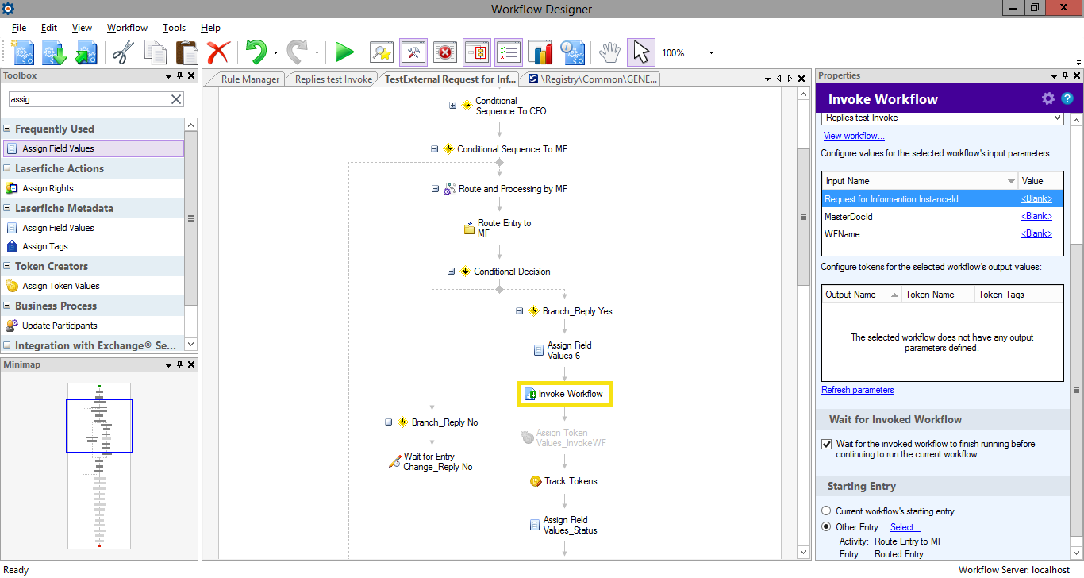

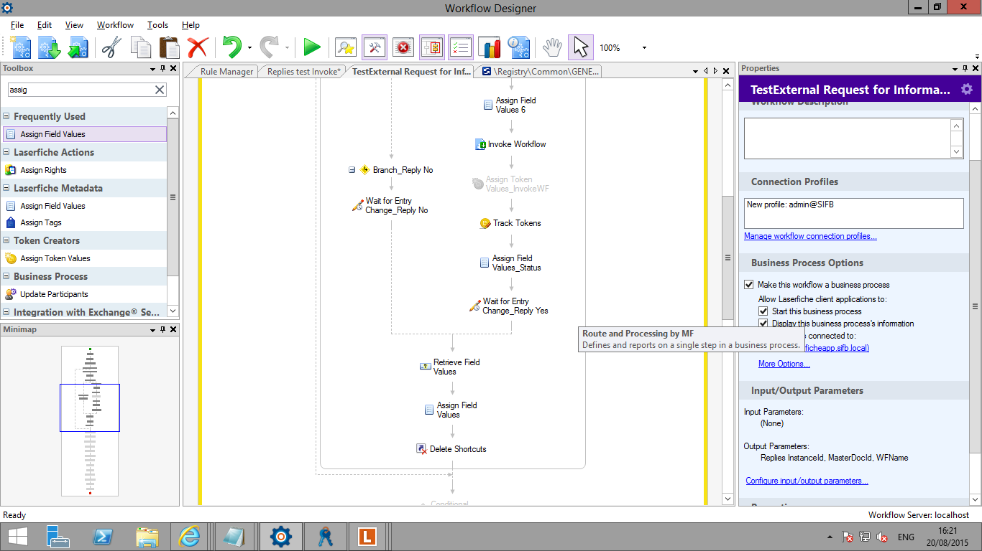

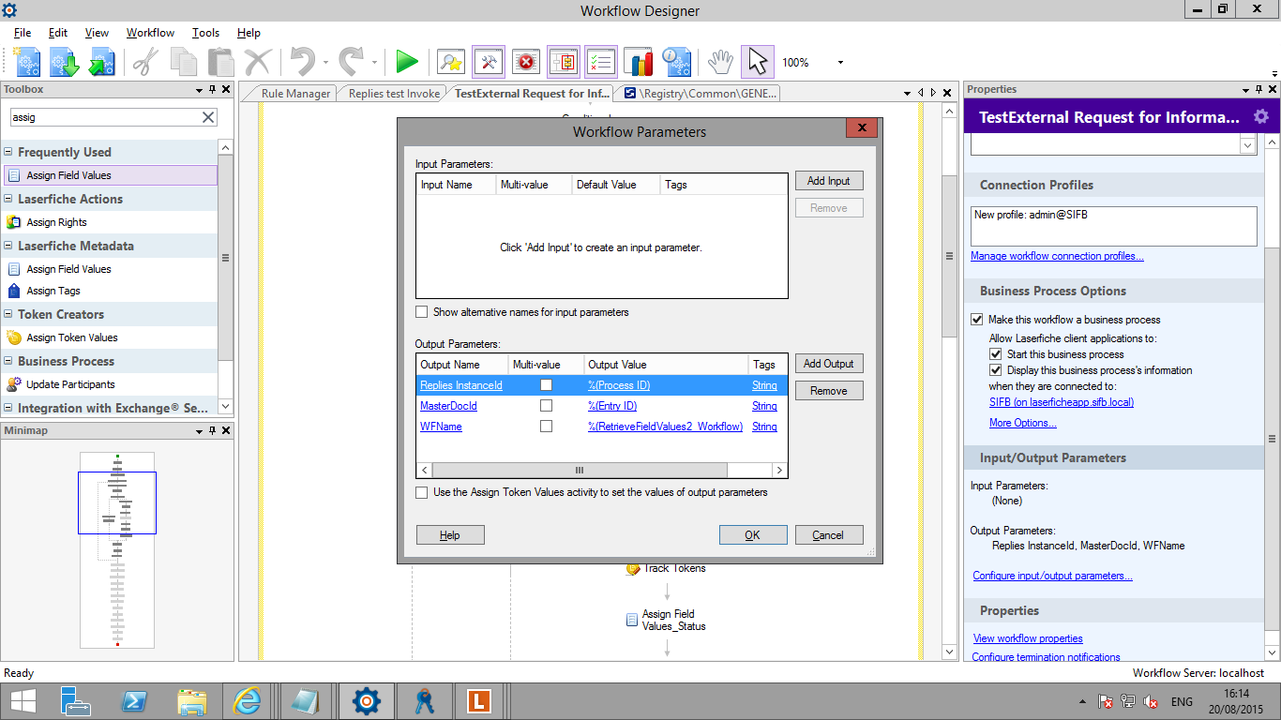

When the shortcut has been placed in MF working folder. MF requires a reply to that shortcut and thus updates a drop-down field by selecting ‘Yes’ and the Status is changed to Awaiting for reply.

The reply workflow (B) is then invoked and this workflow creates a reply between CFO and MF. It is MF who creates a reply as the shortcut is still in his working folder. If he is OK with the reply, he set a field Reply Approved to Approved and another field Reply Status is set to Completed. Please find screenshot of my reply workflow.

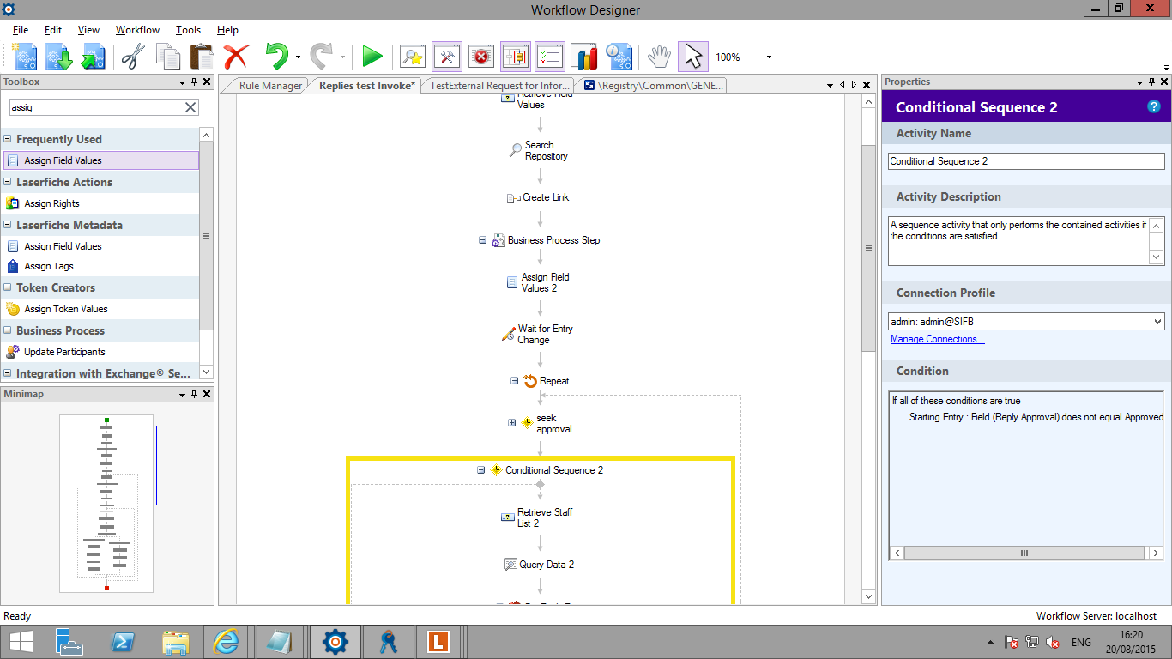

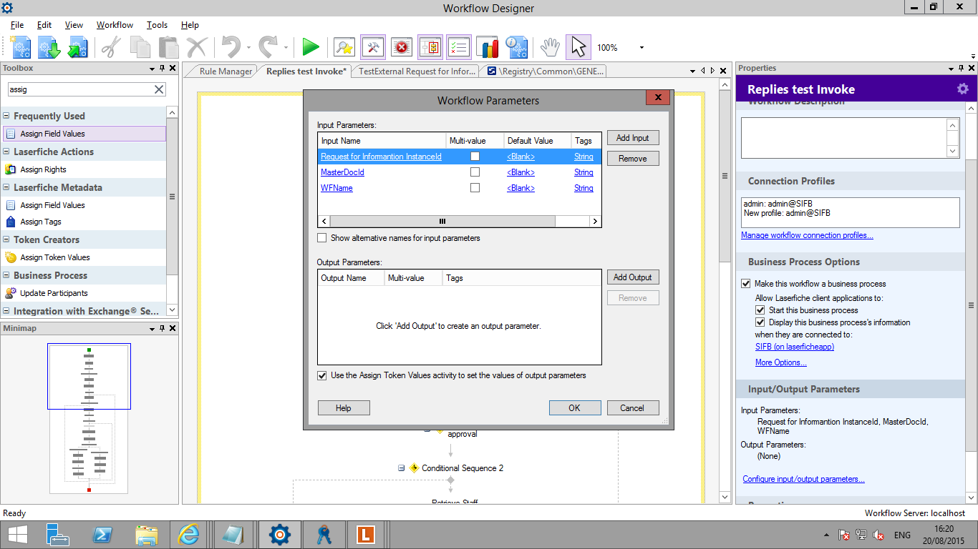

Once, the Reply Status is set to Completed, the invoked workflow B should then be closed.

The Status for Workflow A should be changed to Completed and the shortcut should be deleted from MF working folder.

**Results:**

The invoked workflow (B) is marked as Completed.

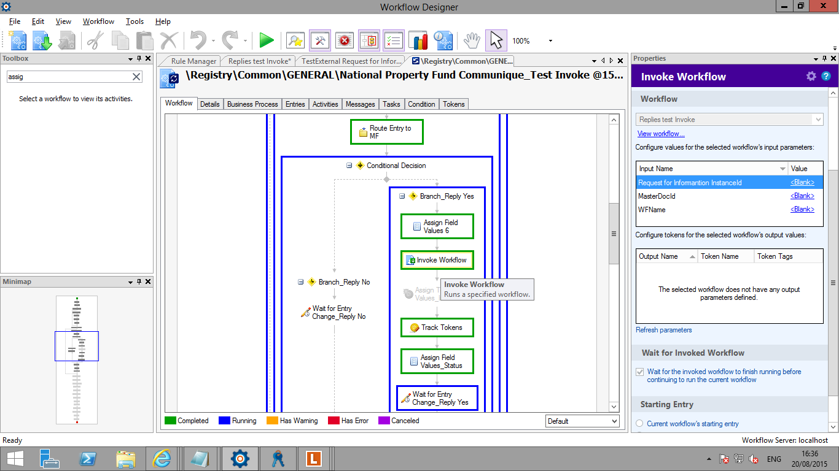

I am getting an error as the invoked workflow is being terminated.

