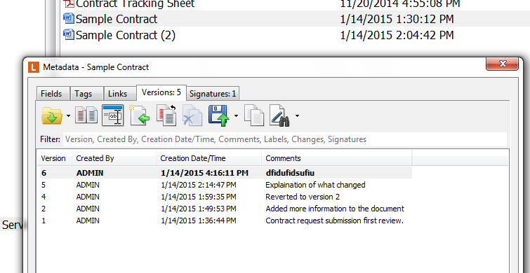

I want Sample Contract (2) to become the current version of Sample Contract.