1. After Submit Forms

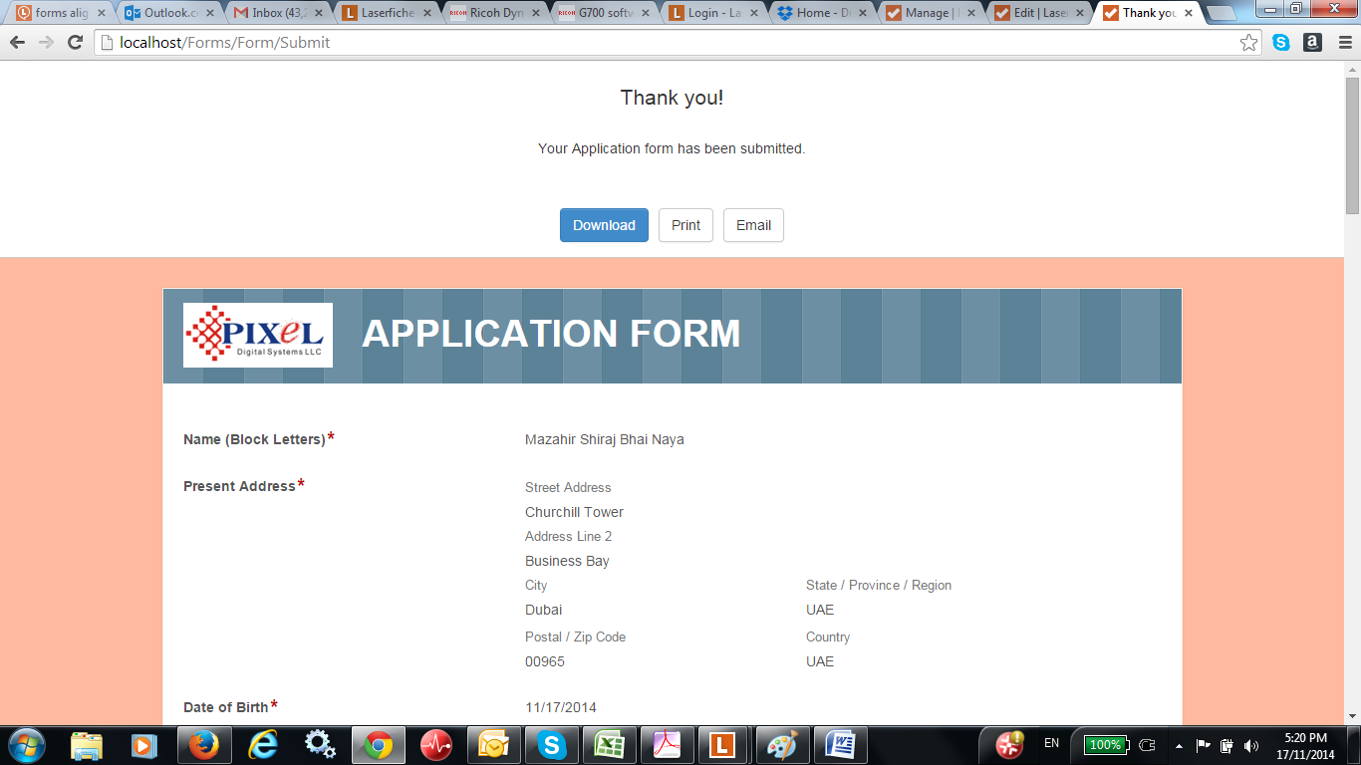

2. Screen Shots from Laserfiche Archive Forms. TIFF or PDF

