* QF sessions are held on an E: drive (SAN attached storage) and the files are written to the C drive.
* QF is installed at a Virtual Server/Machine
* This VM has 4 cores configured

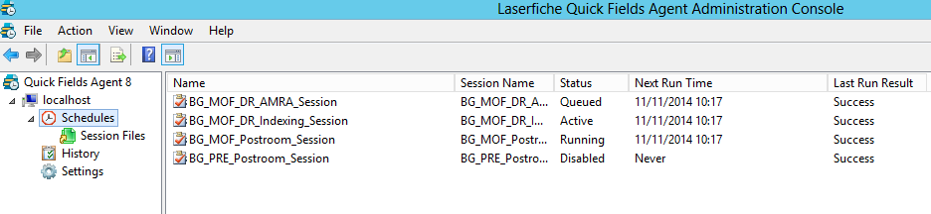

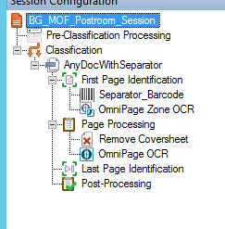

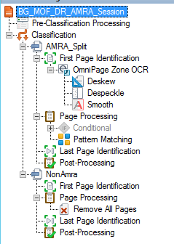

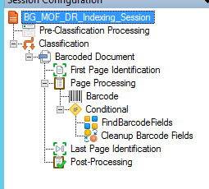

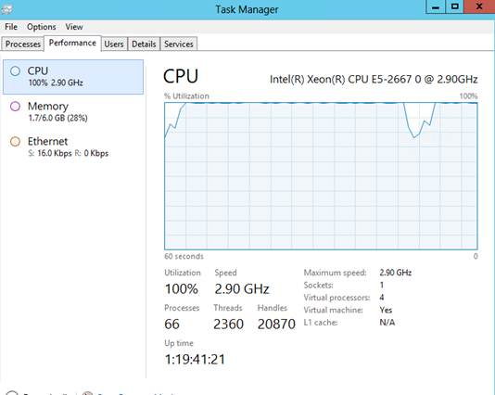

Only one user logged in and not doing much (or anything):

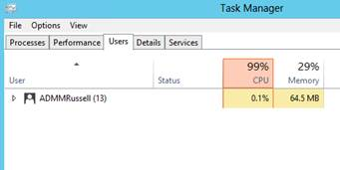

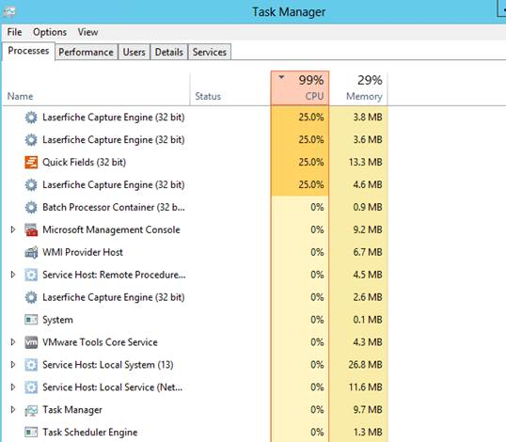



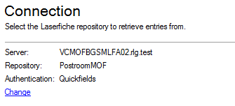

Connect to app server and repo, different ones in different sessions.

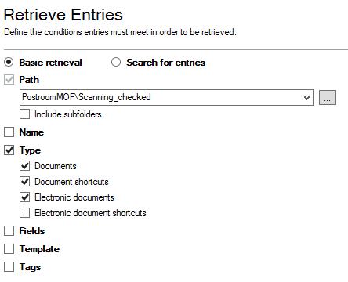

Postroom session, should probably untick the shortcuts and electronic docs, only interested in Tiff Documents

In BG sessions the Fields and template are checked for status values



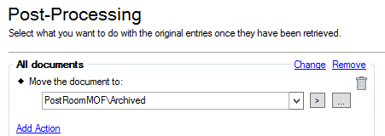

For postroom save to archived folder, but in BG sessions, might just be updating a field, or saving and updating a field.



**Another Observation**:

We can see other LCFE.exe processes start running and terminate (presumably expected behaviour)

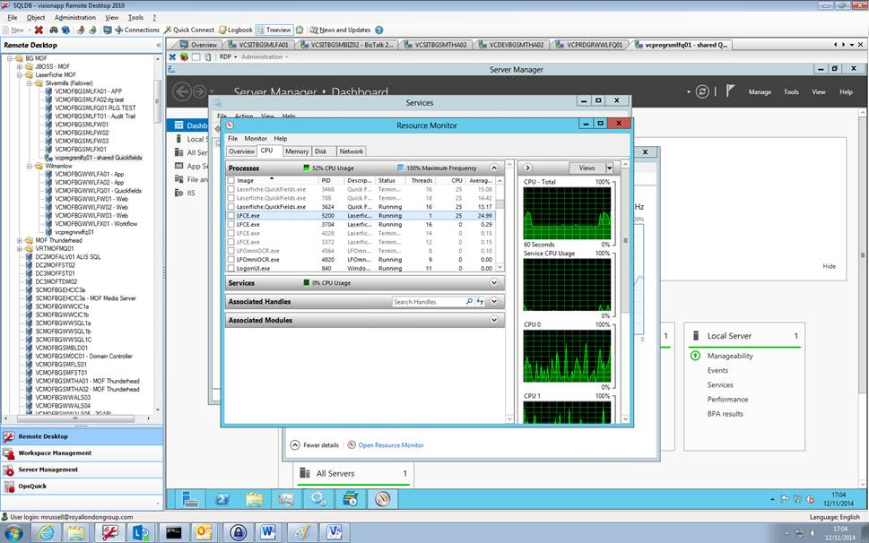

Then multiple LCFE.exe appear to remain and never terminate…..?  This, plus the QF agent process running results in maxed out CPU…..

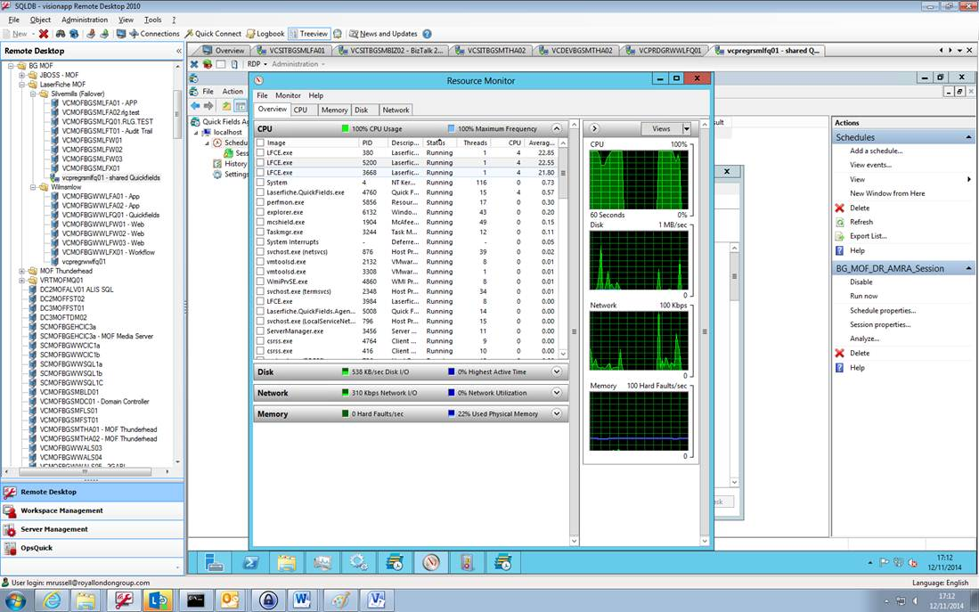

If we shut down the Quickfields service, the LFCE.exe processes remain until the server is rebooted or the process killed.

**Another Server with QF and a Single Session**

This is with 1 schedule and 2 cores (and no users logged in)..”

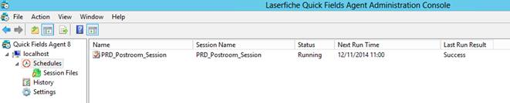

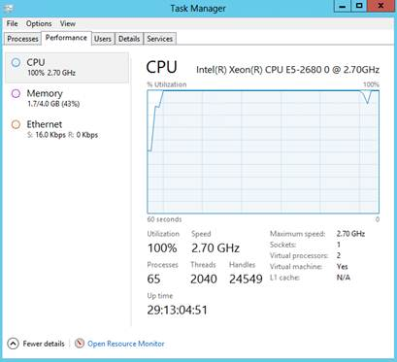

**Default setting configured for QF Agent**

