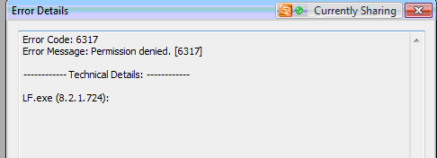

DataNOW Affinity

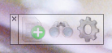

The “plus” connects the 2 applications and allows the user to launch Laserfiche scanning

The “binoculars” allows the user to view documents

The “cogwheel” is not used by end users