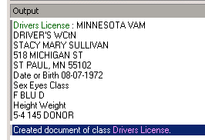

Line 4 – reads 100% accurately

Line 2 – reads 100% accurately

Line 1 – reads 100% accurately

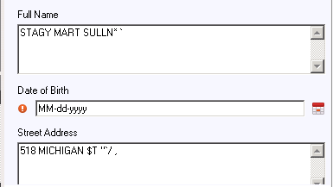

Actual output… Where is it reading??? The above is showing 100% accuracy – but this is obviously wrong☹

For Page Identification, I have a bigger box so is it grabbing that data and using it? Basically, I need to know where to make my corrections for my template information. I did make some adjustments, but it’s not grabbing the right information.

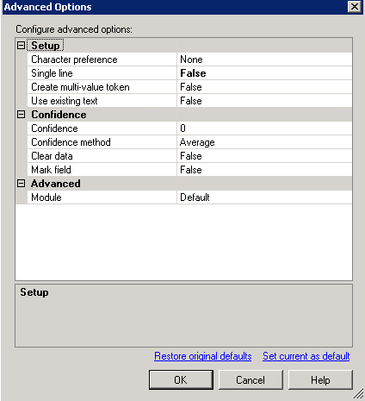

Actual zones to read the areas:

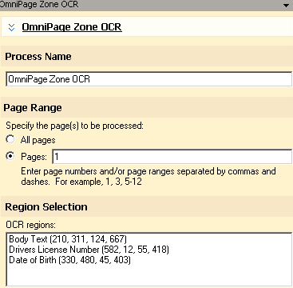

Body Text options (date of birth and DL are separate areas):

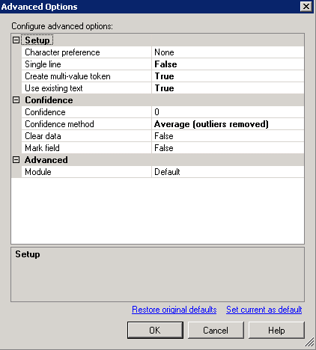

Token for DOB:

