Current Welcome Page with Search Form bookmarks below.

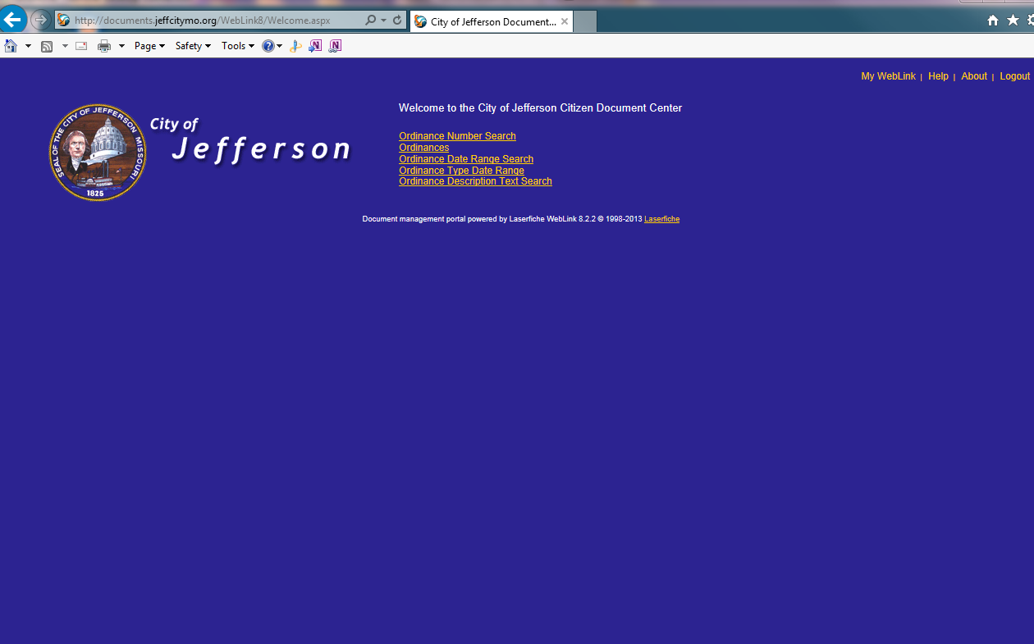

Below is current Browse link, City Clerk, Ordinances Folder. Would be great for Users to have the Welcome Page Search Forms listed in the header of this page

