This form is filled out by two people simultaneously so I have the form set up where they each need to submit a pin number in order to reveal the form.

Step 1 – When the form Opens

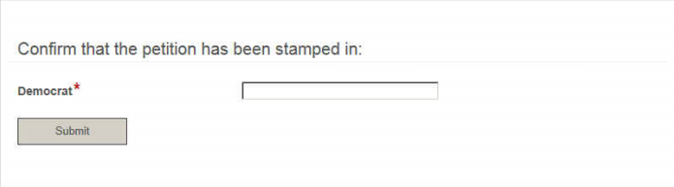

Then I have a field rule that won’t reveal the second sign-in unless the first pin is correct.

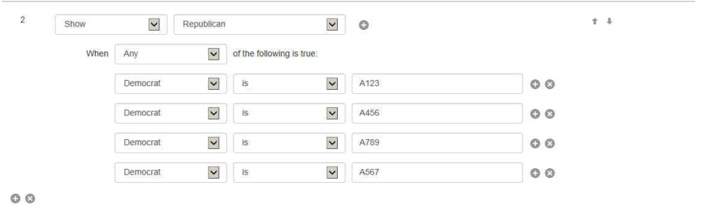

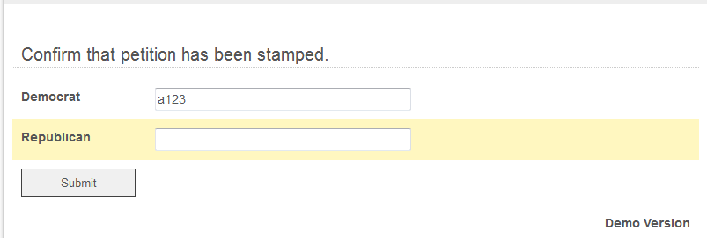

Then a second rule if the Republican field has the correct pin in order to reveal the rest of the form.

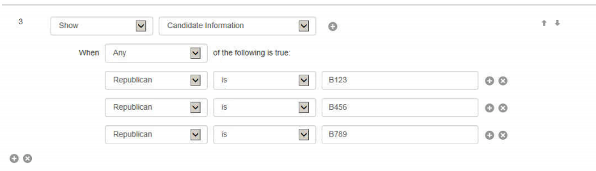

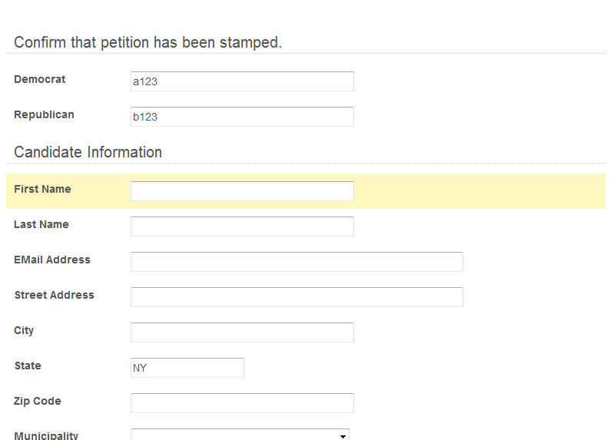

All was working perfectly until I set up a mask on the pin numbers.

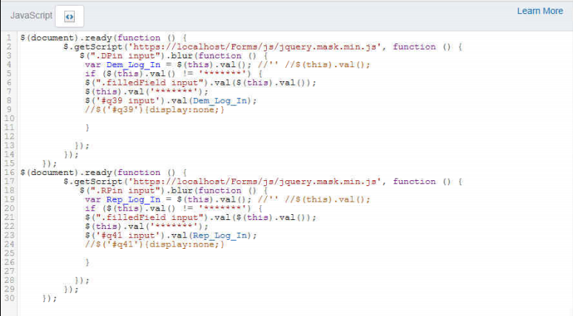

Now the Republican field is revealed until the mask is applied then the field disappears.

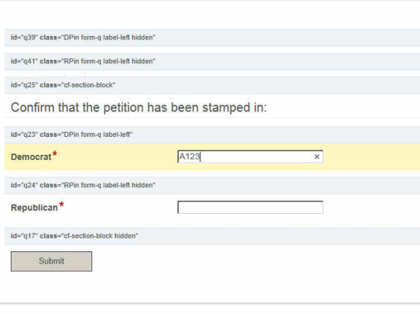

As soon as I tab out of Democrat

