Form opened in IE on the forms server.

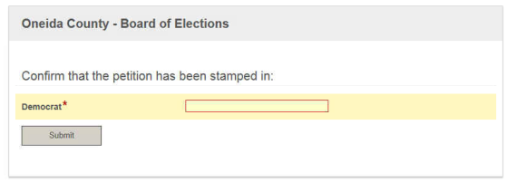

Same form opened on the workflow server. (I don’t have any PCs available to me at this time).

