This is the only group the user is assigned:

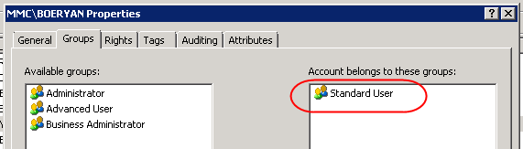

The ability to manage entry access is not enabled for this user, or from the assigned group:

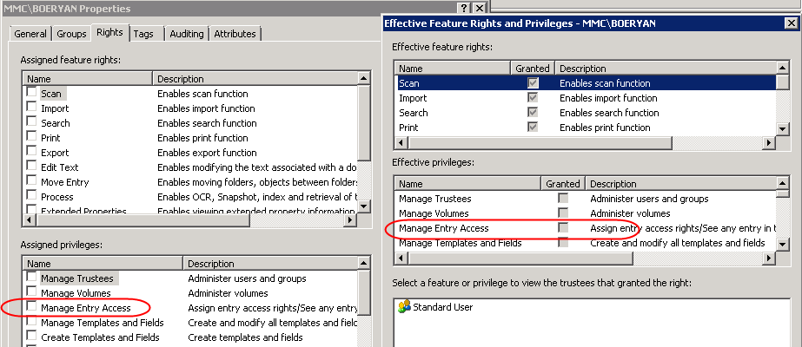

Looking at the security for subfolders of a location, reading and writing security is denied:

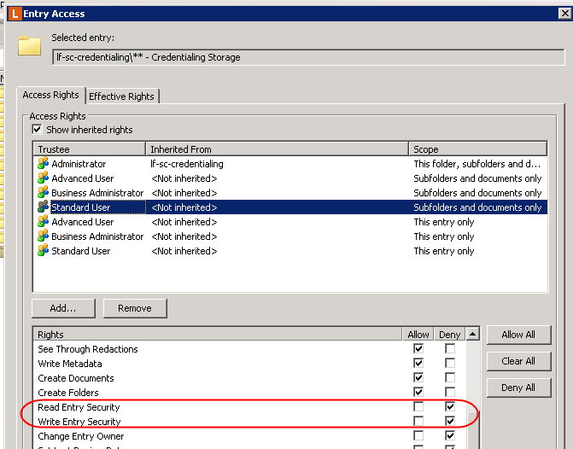

If I create a new sub-folder, applying the above security, it does carry over to access rights:

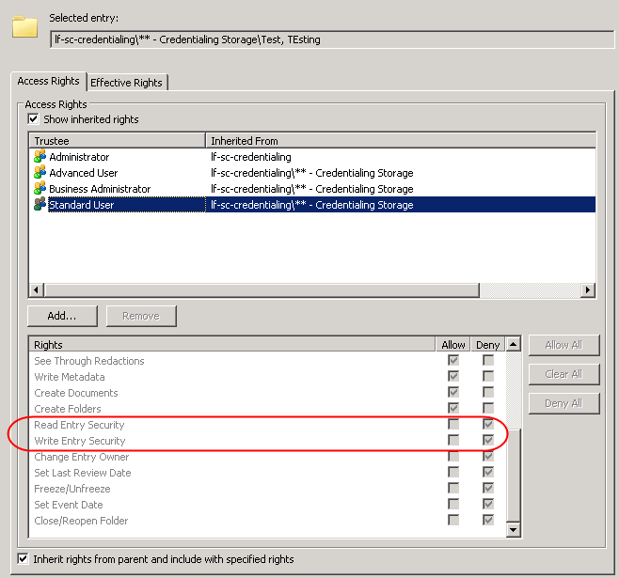

However, when I look at the effective rights, something somewhere is auto-turning on the read and write security permissions for my user on any folders my user creates:

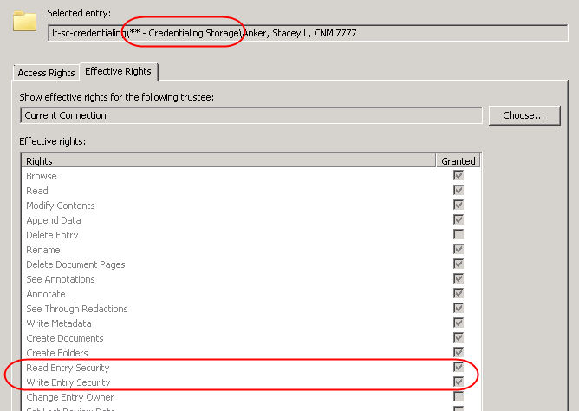

**This doesn’t happen to folders created by other users, just to folders that the user creates themselves.**