Here’s how I have the security set up:

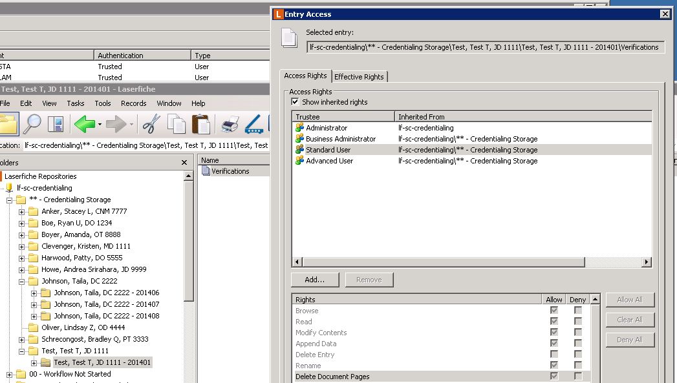

Here are my user’s effective rights:

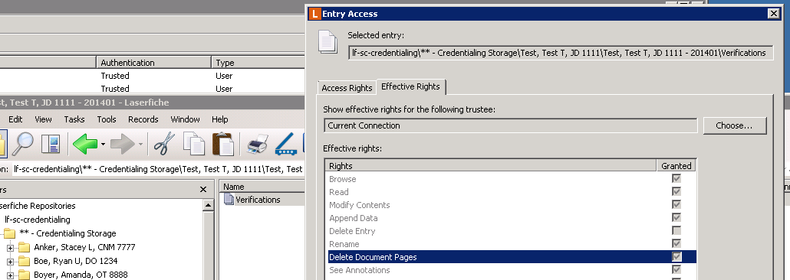

Here is what that user sees when trying to delete a document page from this document:

