This is the connection profile for the workflow:

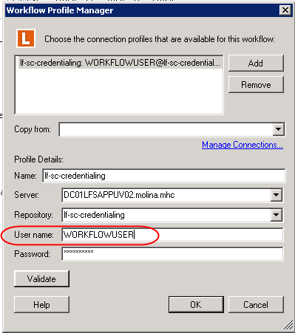

This is the config for this repository:

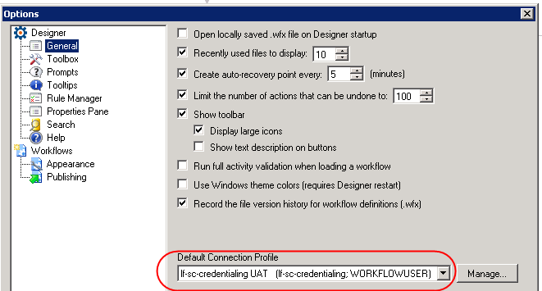

This is the security for that user, you can’t see it all, but every box is checked, as this user is part of the ‘administrator’ group:

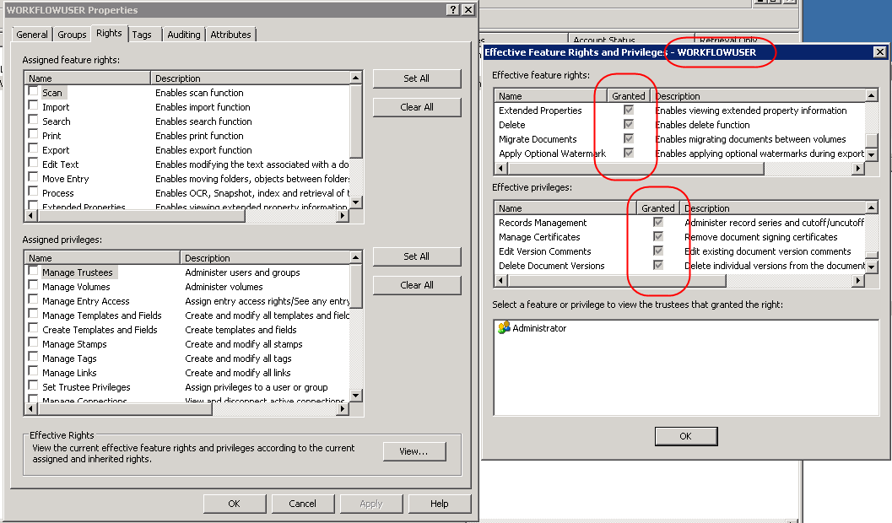

User config on workflow template:

