What I see when I try to manually type in the value I know exists in my dynamic SQL table:

If I click on the drop-down arrow, it’s just blank values.

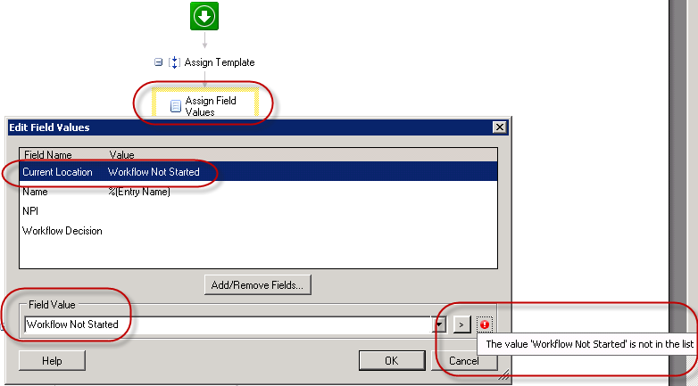

What my dynamic table shows when I review from within the Admin Console in the workflow template:

