Default Template

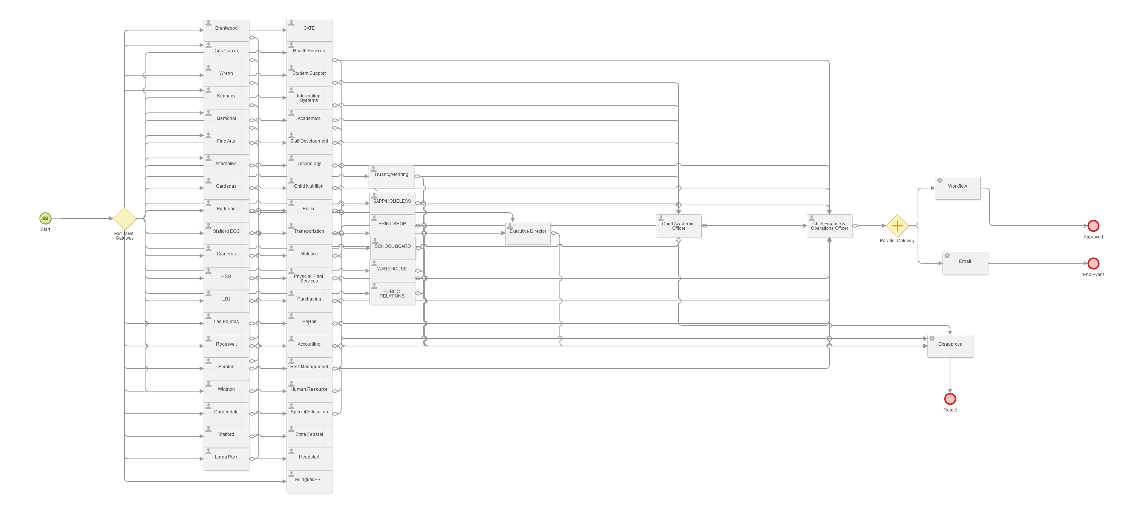

Template without default template but needs all users in approval path.

