LaserRepository

Laserfiche Presales is proud to present you the new LaserRepository. This repository contains 6 demos showing the latest Laserfiche features. The demos have multiple entry points and ways of being run, so we suggest you familiar yourself with the process and take a look at the workflows to understand how they were built, how they run and how to best present them.

The main administrator is **SuperAdmin** with password **s**. All users’ passwords are the first letter of the user name, so Ralph Records’ password is r. The only user whose password is not one letter is the **Admin** user, password is **admin**.

**Setting up the repository**

**Note: these videos are from the DemoRepository. Please replace any instance of DemoRepository with LaserRepository.**The following components must be installed: Laserfiche 9, Workflow 9, Forms 9, Quick Fields 8.0 or higher, SQL Server 2008 R2 (Express is fine).

[Registering and setting up the repository](http://webmeeting.laserfiche.com/p5j7n9eth0r/)

[Setting up Quick Fields sessions and Workflows](http://webmeeting.laserfiche.com/p3grulcuycf/)

Please move the Demo Files, Forms Business Processes and LaserRepository folders to your C Drive, directly under C:\

**Demo Video Tutorials**

https://www.laserfiche.com/en-us/VARPortal/Post/sales-tools/laserrepository

[AP Processing](http://laserfiche.webex.com/laserfiche/ldr.php?AT=pb&SP=MC&rID=65271237&rKey=78e1d13815f4a474)

[Bank Loan Processing](http://webmeeting.laserfiche.com/p2vi6zbbw3x/)

[Case Management](https://laserfiche.webex.com/laserfiche/ldr.php?AT=pb&SP=MC&rID=65274307&rKey=7dc0c550d7cb6fb9/)

<http://laserfiche.webex.com/laserfiche/ldr.php?AT=pb&SP=MC&rID=65274307&rKey=7dc0c550d7cb6fb9>

[Higher Education](http://laserfiche.webex.com/laserfiche/ldr.php?AT=pb&SP=MC&rID=65336002&rKey=ec6b8ab43e628b4d)

[HR Onboarding with Forms](http://laserfiche.webex.com/laserfiche/ldr.php?AT=pb&SP=MC&rID=65305107&rKey=23130b119ee4d5a9) and [HR Onboarding with Quick Fields + Forms](http://laserfiche.webex.com/laserfiche/ldr.php?AT=pb&SP=MC&rID=65298652&rKey=14f7f74167aae318)

[Travel Request](https://laserfiche.webex.com/laserfiche/ldr.php?AT=pb&SP=MC&rID=65295102&rKey=b691780979d58fe6)

We will be adding more demos throughout the year and sharing them on the [Presales place](https://www.laserfiche.com/ChannelWeekly/Category/support/presales-questions).

Setting up Forms look ups

Some of the forms that we’ve created contain a lookup into the ExternalTables database in SQL. Here’s what you’ll need to do do reconfigure the lookups on the Forms.

1. Import all the **Business Process Forms** located under the **Forms Business Processes folder**.
2. Log into Forms as the **System Administrator**. On the top right, click on the **Settings** icon and select the **Data Sources** tab.  
     
   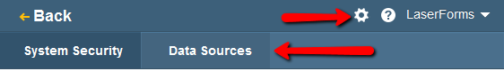
3. Add a new **datasource** and type in the SQL Server info, point it to the **ExternalTables** database and type in your account and password.  
   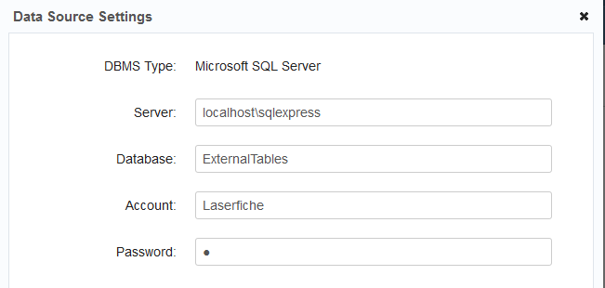
4. To make things easier, select all the business processes
5. For the following BPs, configure the lookup under the “Rules” for the form.  
     
   **Purchase Order BP: Purchase Order Form**  
   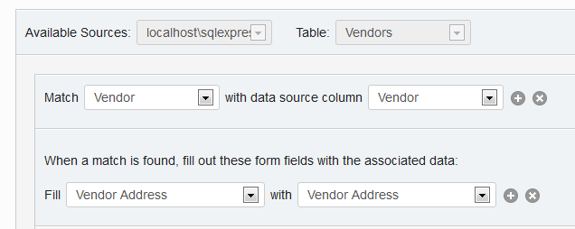  
     
   **Case Management Form Submission BP: Starting Form**  
   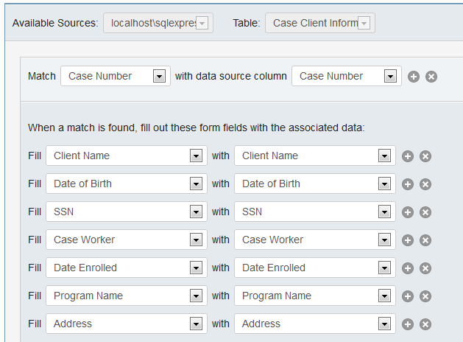  
     
     
   **Laser University Financial Aid BP: Financial Aid Form**  
   