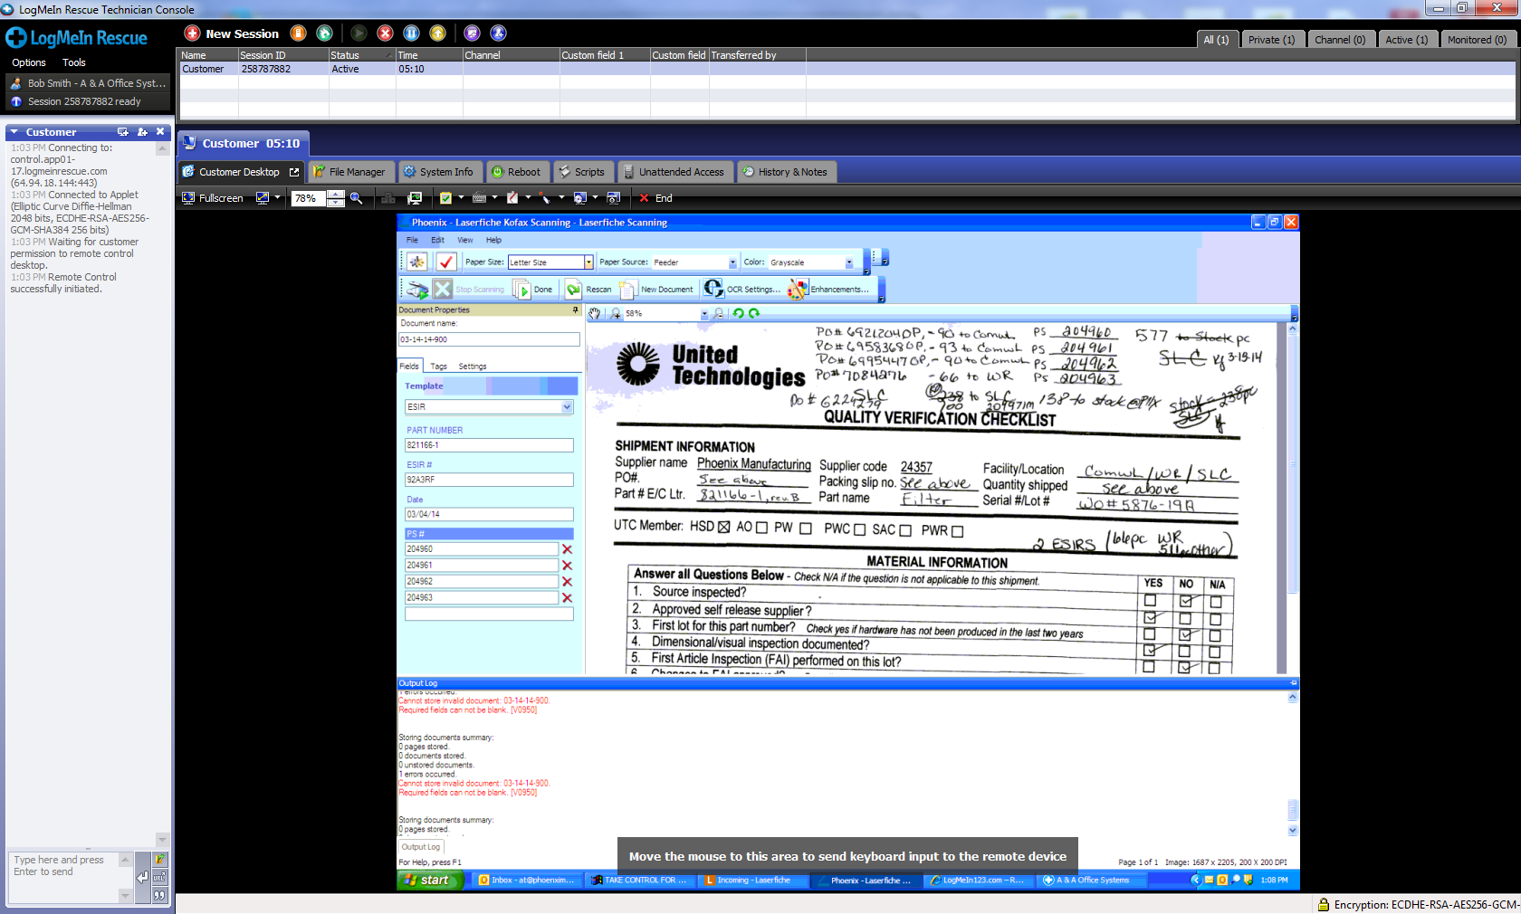

Client Version is 9.1.0.4

The problem is this: Using normal Laserfiche Scanning. For a template with a required field. The user adds data to all required fields but the document won’t allow itself to be stored.