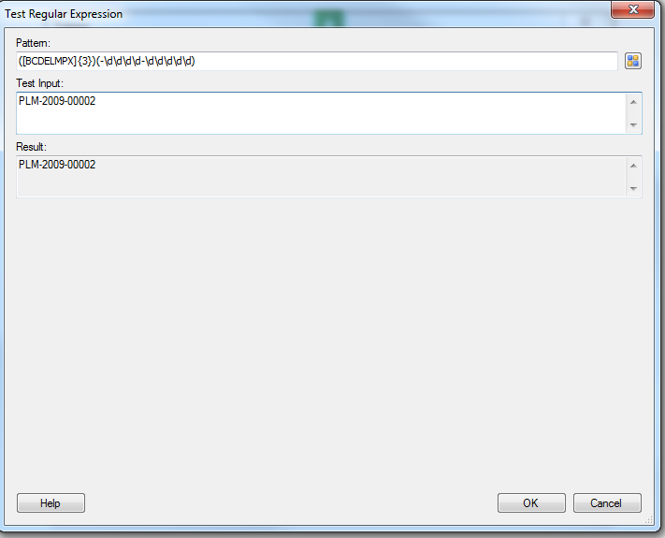

This is the expression I used.

T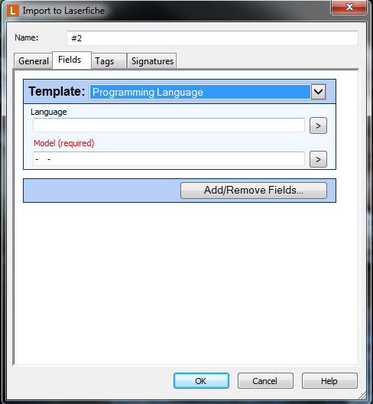

This is what the client would want, but then again this only works when I use the regular expression as I did in the image BELOW.

