•Is this an upgrade installation? •If so, from what version of workflowNo this is a new installation of workflow 9.1.1  
  
•When you open the configuration manager, does the workflow server say 'Not configured' or 'Please click to upgrade'?   
Yes   
  
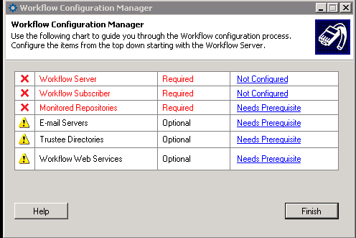  
  
•Do you know when this error is reported? •Is it when you click on the link from the configuration manager   
When I click on the link to configure the server and I click the dropdown list to give me all the SQL Servers on the network.

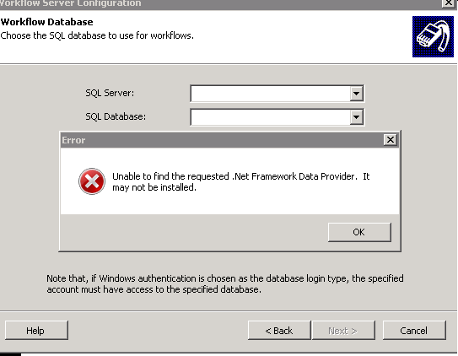

(note: initially user reported the message as above. The below error is the time I am hearing about it)   
