How it looks originally when opens.
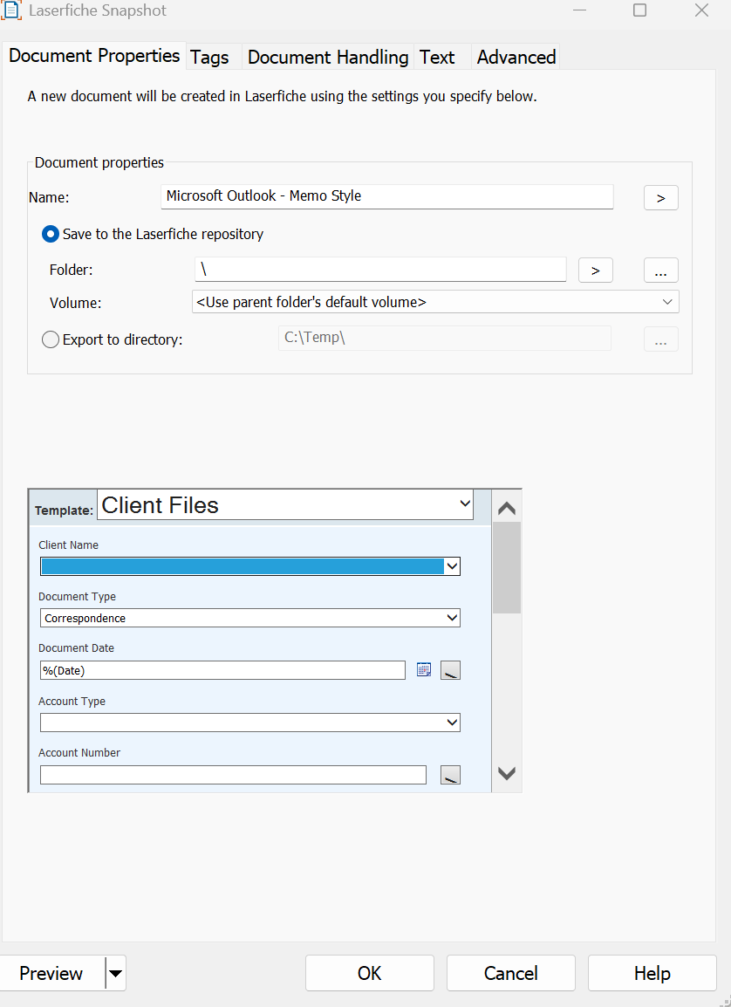
Is there a way to make the template window bigger to show all the fields so we don’t have to make this pop out window so big or long to see everything?

