Workflow start rule is scheduled to run at 1:00 AM daily. The workflow starts at 1:00 AM every morning, just like the rule says. The problem is the workflow is also starting at 8:00 PM.

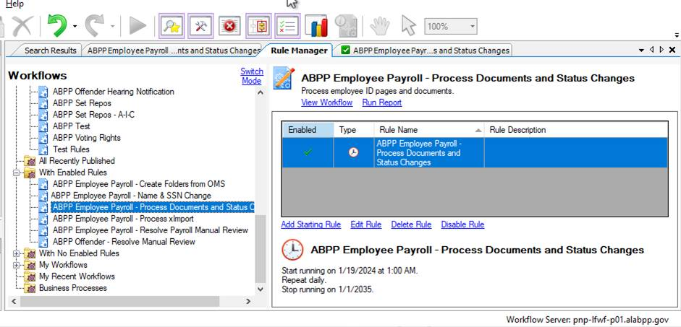

This set shows the results from the entry with a Start Time of 1/29/2024 8:00:13 PM.

Notice the difference between the start time in the Details tab (above), the Activities tab (below) and the Tokens Tab (below).

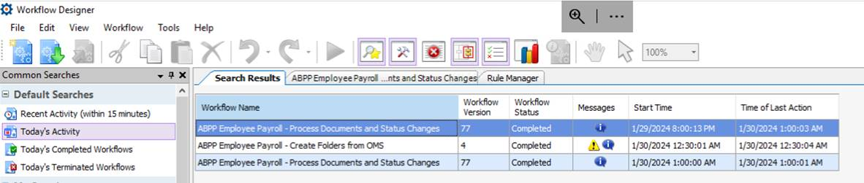

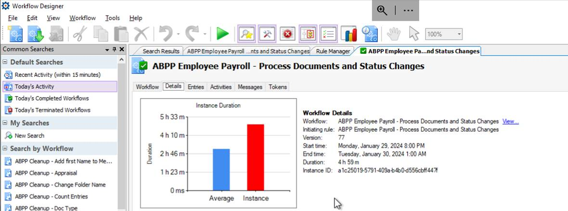

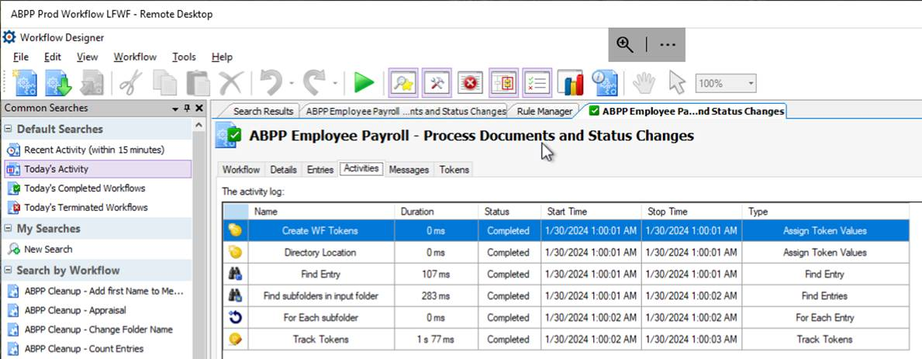

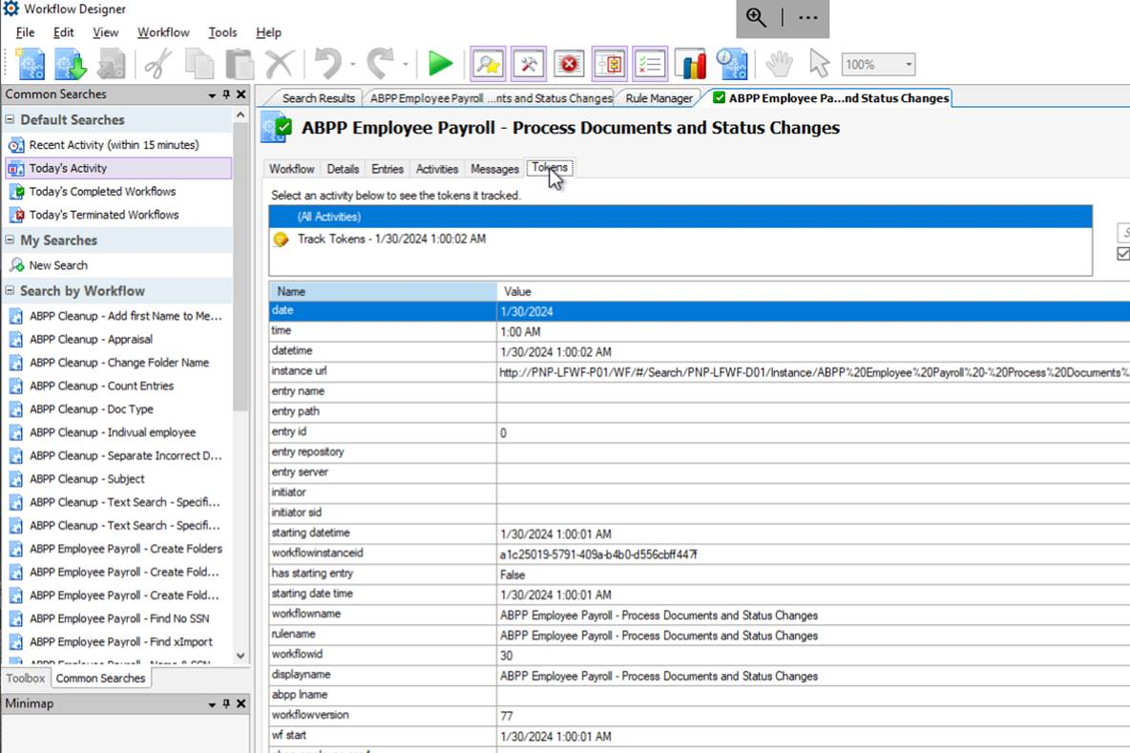

This set shows the results from the entry with a Start Time of 1/30/2024 1:00:00 AM.

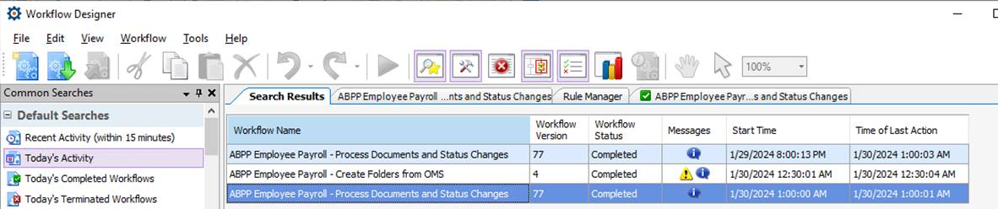

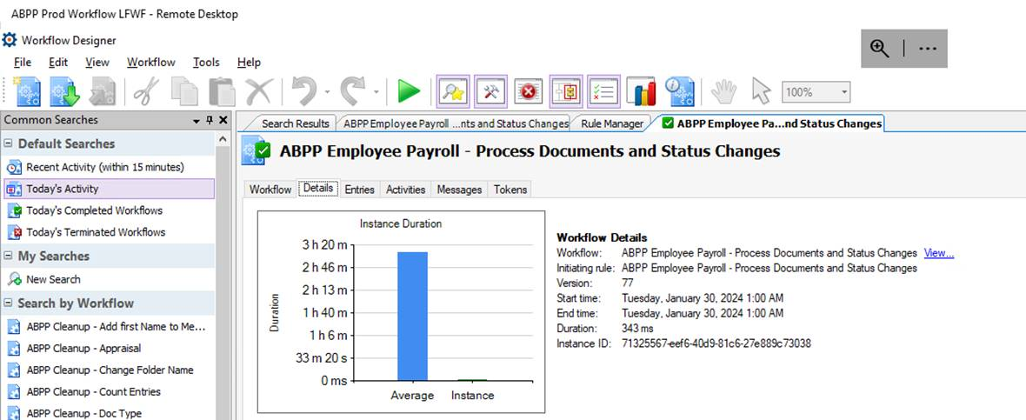

Notice the same start times in the Details tab (above), the Activities tab (below) and the Tokens Tab (below).

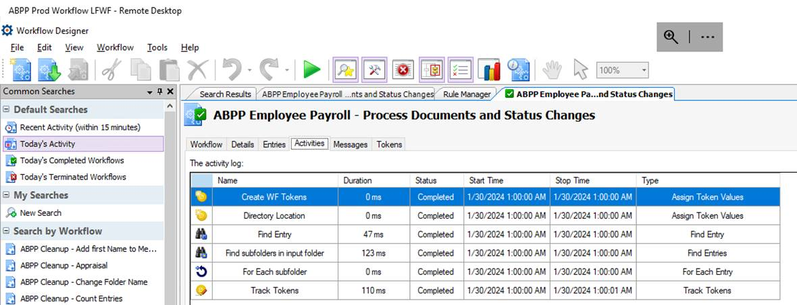

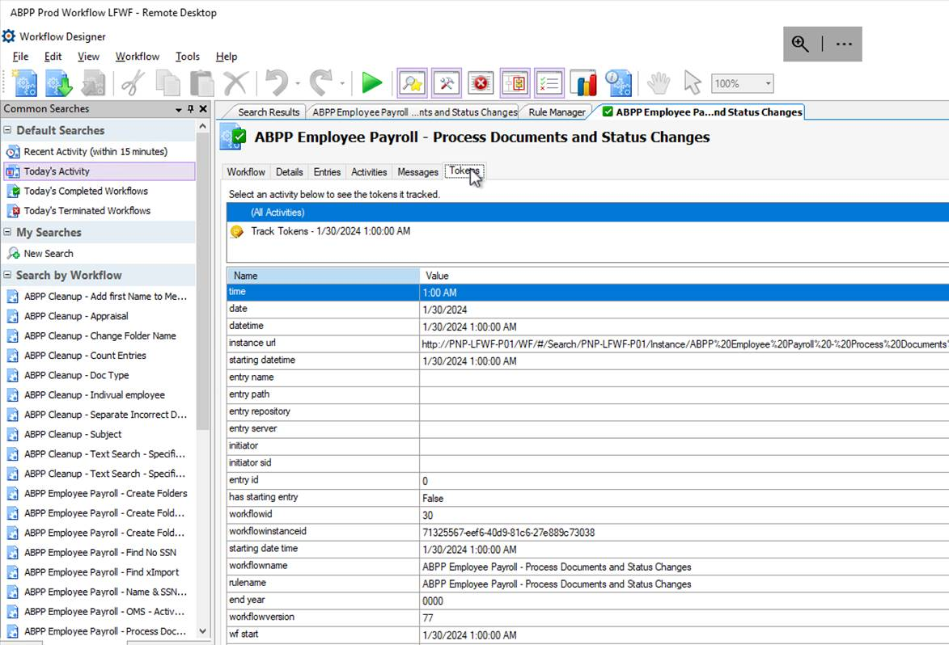

Here is a screen print from Windows Scheduler. There are only 2 entries for workflows. ‘ABPP Employee Payroll - Process Documents and Status Changes’ has a workflowid of ‘30’ shown here as ‘WF8_PNP-LFWF-P01_WF30_R22’. ‘ABPP Employee Payroll - Create Folders from OMS’ has a workflowid of ‘78’ shown here as ‘WF8_PNP-LFWF-P01_WF78_R20’. If you look at the scroll bar in the section that contains Name, Status, and Triggers, you will see there no other workflow tasks. ‘WF8_PNP-LFWF-P01_WF30_R22’ only shows one execution per night.

