Form is very basic
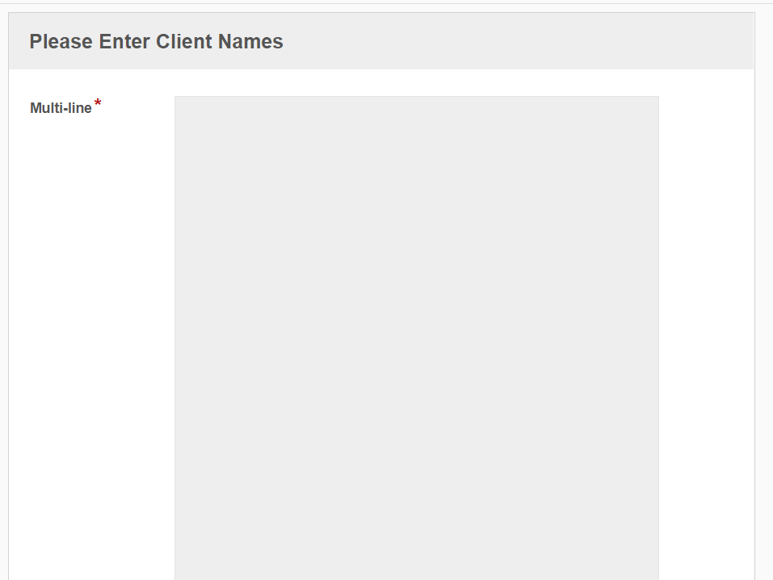
Process is also basic
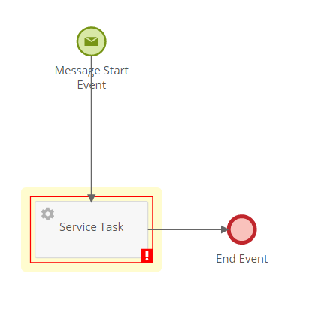
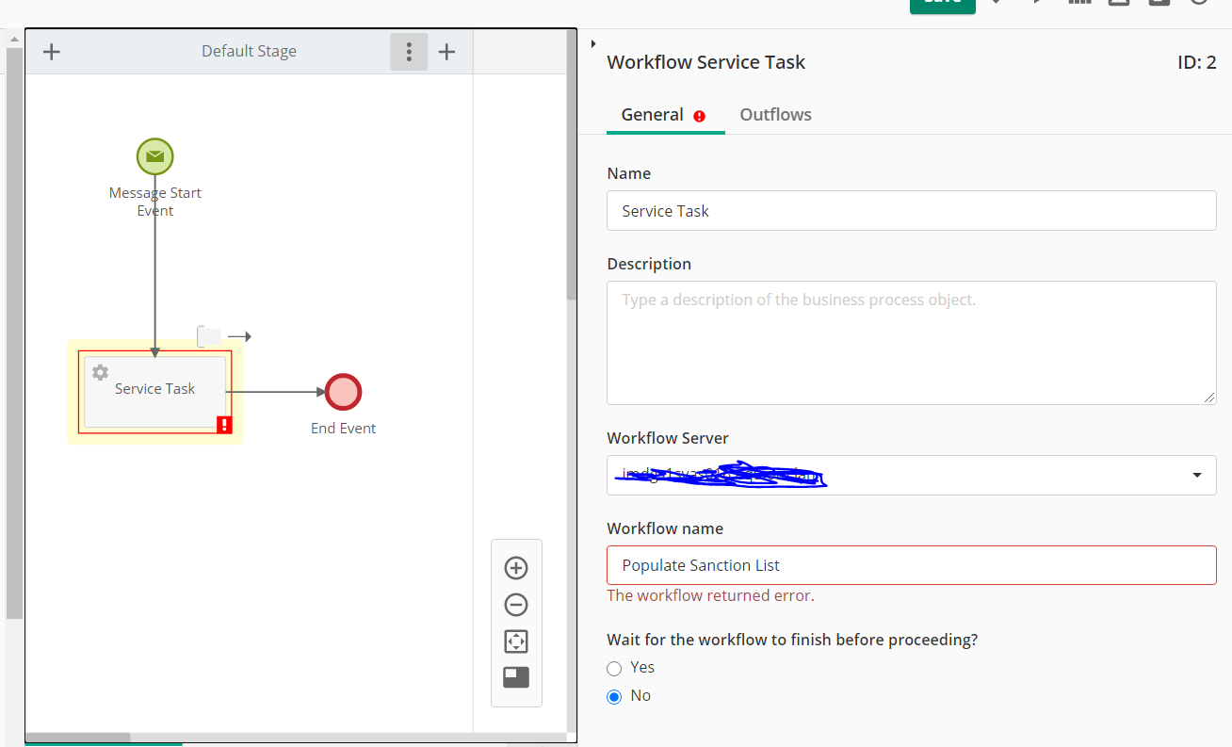
An unexpected error occurred.
The workflow only writes the data to a database for the time being.
Event Viewer on forms server

+ | System

- | Provider

 |  |  | [ Name] | Laserfiche Workflow Subscriber

- | EventID | 100

 |  |  | [ Qualifiers] | 0

 | Level | 2

 | Task | 0

 | Keywords | 0x80000000000000

- | TimeCreated

 |  |  | [ SystemTime] | 2023-10-04T16:02:39.295970300Z

 | EventRecordID | 60265

 | Channel | LFWorkflow

 | Computer | IMDGS1SVAS018.equiom.lan

 |  | Security
- | EventData

Timestamp: 2023-10-04 16:02:39.295 Local Time: 04/10/2023 17:02:39 Category: Errors Machine: IMDGS1SVAS018 Severity: Error Application Domain: Laserfiche.Workflow.Subscriber.exe Process Id: 4988 Process Name: C:\Program Files\Laserfiche\Workflow\Laserfiche.Workflow.Subscriber.exe Win32 Thread Id: 5776 - Subscriber Thread Thread Name: Subscriber Thread Message: <Exception handlingInstanceId="53f9ae50-8ceb-4c36-baf6-35f389ba9d7e"> <Description>An exception of type 'Laserfiche.Workflow.WFSOException' occurred and was caught.</Description> <DateTime>2023-10-04 17:02:39Z</DateTime> <ExceptionType>Laserfiche.Workflow.WFSOException, Laserfiche.Workflow.ServerObjects, Version=8.3.0.0, Culture=neutral, PublicKeyToken=d8428ff9263e6cda</ExceptionType> <Message>The Workflow database is not configured. Run the Configuration Manager to resolve this issue. [0198-WF1]</Message> <Source>Laserfiche.Workflow.ServerObjects</Source> <HelpLink>Error Code 198</HelpLink> <Property name="Trace">Laserfiche.LaserficheException: The Workflow database is not configured. Run the Configuration Manager to resolve this issue. [0198-WF1] at Laserfiche.Workflow.Database.DbHelper.CreateSqlConnection(String dbName) at Laserfiche.Workflow.Database.LaserficheManagementHelper.InsertRegisteredSubscriber(String subscriberName) at Laserfiche.Workflow.Runtime.LaserficheManagementSystem.AddRegisteredSubscriber(String subscriberName) at Laserfiche.Workflow.Operations.Subscriber.RegisterOperation.Execute(WcfOperationContext context) at Laserfiche.Workflow.Runtime.Systems.SubsystemCommandHandler.ProcessExecuteCommand(ExecuteOperationCommand command) at Laserfiche.Workflow.Runtime.WcfSubsystem.ExecuteOperation(OperationCommand operation) </Property> <Property name="IsCommunicationError">False</Property> <Property name="ServerExceptionType">Laserfiche.LaserficheException</Property> <Property name="TargetSite">Laserfiche.Workflow.Connection.OperationResult ExecuteCommand(Laserfiche.Workflow.Connection.OperationCommand)</Property> <Property name="HResult">-2146233088</Property> <StackTrace>Server trace: Laserfiche.LaserficheException: The Workflow database is not configured. Run the Configuration Manager to resolve this issue. [0198-WF1] at Laserfiche.Workflow.Database.DbHelper.CreateSqlConnection(String dbName) at Laserfiche.Workflow.Database.LaserficheManagementHelper.InsertRegisteredSubscriber(String subscriberName) at Laserfiche.Workflow.Runtime.LaserficheManagementSystem.AddRegisteredSubscriber(String subscriberName) at Laserfiche.Workflow.Operations.Subscriber.RegisterOperation.Execute(WcfOperationContext context) at Laserfiche.Workflow.Runtime.Systems.SubsystemCommandHandler.ProcessExecuteCommand(ExecuteOperationCommand command) at Laserfiche.Workflow.Runtime.WcfSubsystem.ExecuteOperation(OperationCommand operation) Client trace at Laserfiche.Workflow.Internal.WorkflowServerClient.ExecuteCommand(OperationCommand data) at Laserfiche.Workflow.WorkflowServerClientExtensions.ExecuteCommandInternal(IWorkflowServerApi api, ExecuteOperationCommand command) at Laserfiche.Workflow.Subscriber.Runtime.LaserficheSubscriber82.RegisterSubscriber() </StackTrace> <additionalInfo> <info name="MachineName" value="IMDGS1SVAS018" /> <info name="TimeStamp" value="04/10/2023 16:02:39" /> <info name="FullName" value="Microsoft.Practices.EnterpriseLibrary.ExceptionHandling, Version=5.0.414.0, Culture=neutral, PublicKeyToken=31bf3856ad364e35" /> <info name="AppDomainName" value="Laserfiche.Workflow.Subscriber.exe" /> <info name="ThreadIdentity" value="" /> <info name="WindowsIdentity" value="NT AUTHORITY\SYSTEM" /> </additionalInfo> </Exception>

