When I right click on the invoice that was approved by Alex, under the Metadata should have his name as the creator but mine is blank. 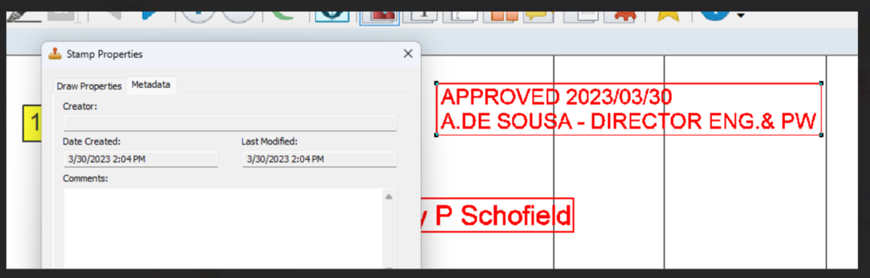

Sarah’s shows the creator information.

