LF Forms v11 – add 1 by 1?
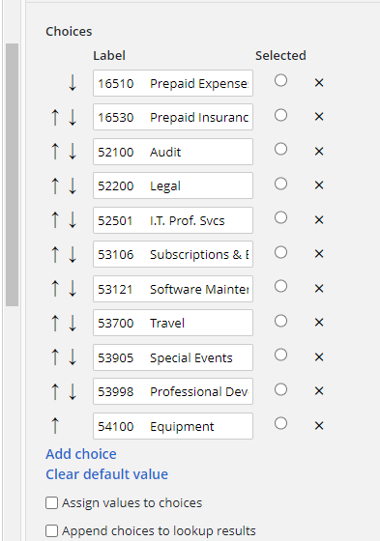

LF Forms v10 – add en masse?
