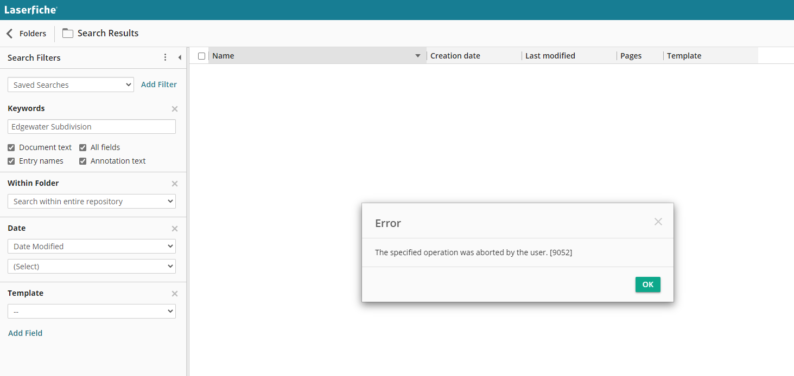
STRANGE RESULTS – WHEN NORMAL USERS SEARCH

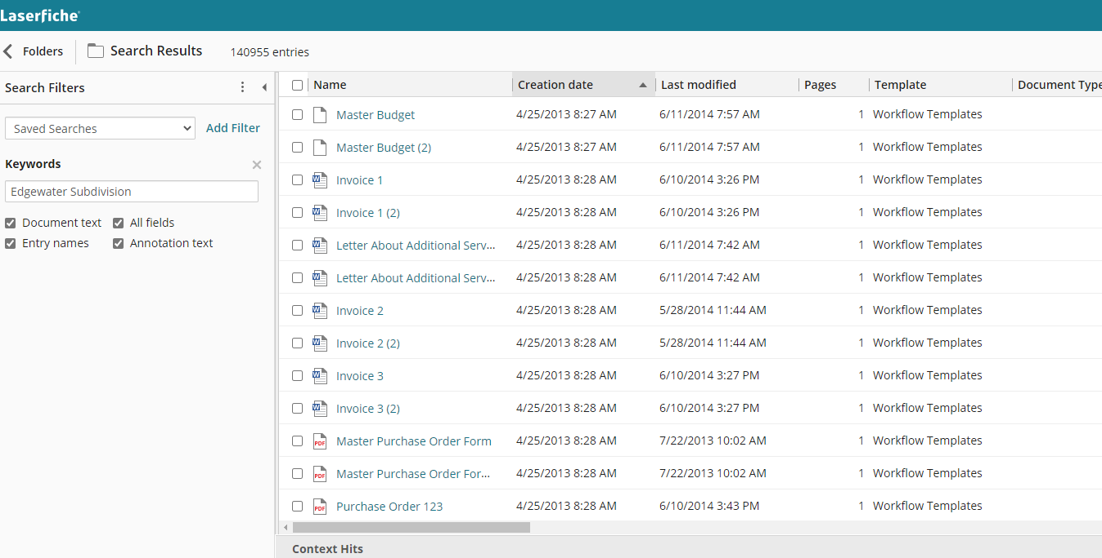
STRANGE RESULTS

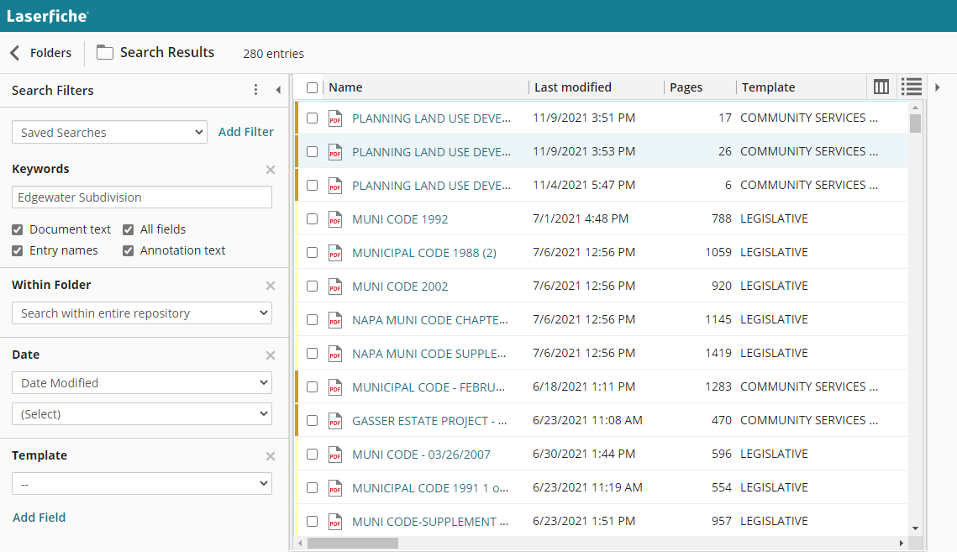
CORRECT RESULTS WHEN ADMIN SEARCHES

