Scenario 1 – customer ID matches (By name and ID) a customer file/folder in repository and confirmed by selecting “Yes” to customer match question. Submit should appear.
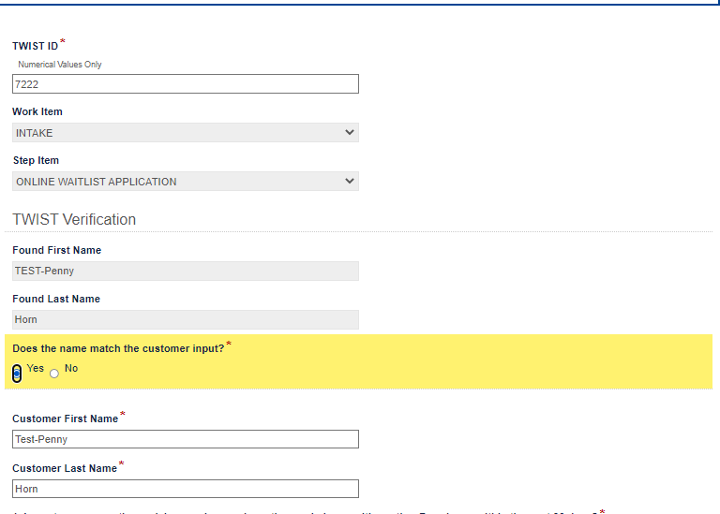
Scenario 2 – customer ID does not match a customer file/folder in repository and confirmed to be new client by selecting “Yes” to new client question. Submit button should appear.
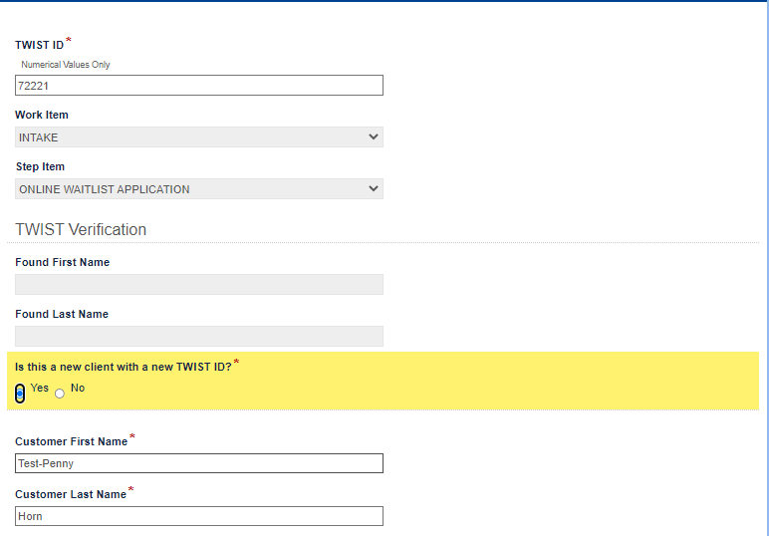
Scenario 3 (Not a logical scenario but a scenario we want to solve for) customer ID does not match a customer file/folder in repository and confirmed to be new client by selecting “Yes” to new client question. But instead of proceeding forward the user changes the ID to a value that does a return value in Found name fields and selects “No” which means the names do not match. The submit button should not appear due to the “No” choice but, in this case, the submit will still appear because the previously selected “Yes” to the new client question still exists even though hidden from view.
