**Codes not working in CSS**

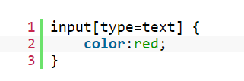

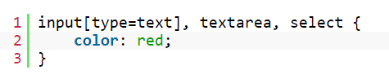



**Working in CSS**

