PDFs show differently for READ ONLY users

Admin user desktop client

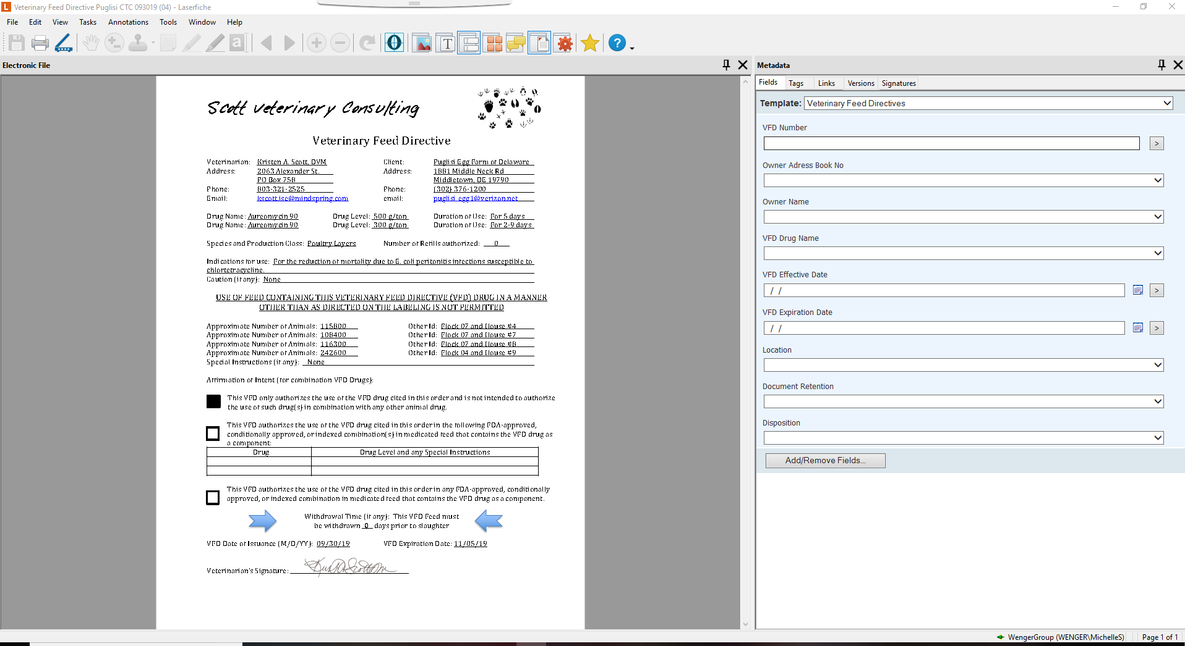

Same Admin user using Web Client

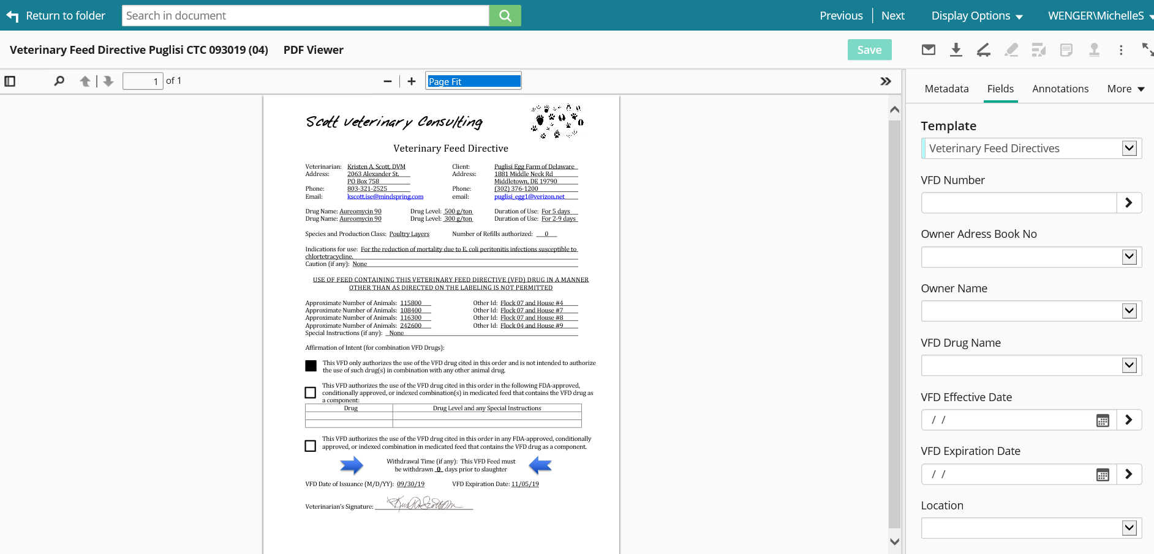

Logo and signature is visible for this user on SAME document in both LF clients.

READ ONLY USER accessing SAME document:

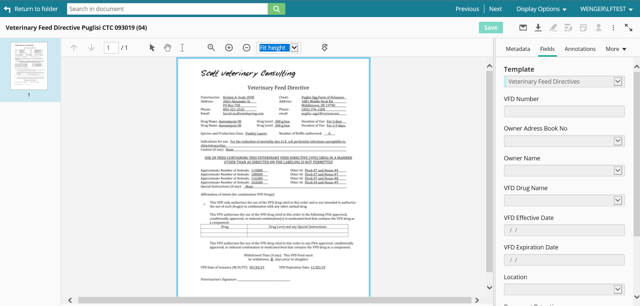

No logo or signature

PDFs show different layers in Web vs. desktop client

Admin user desktop client

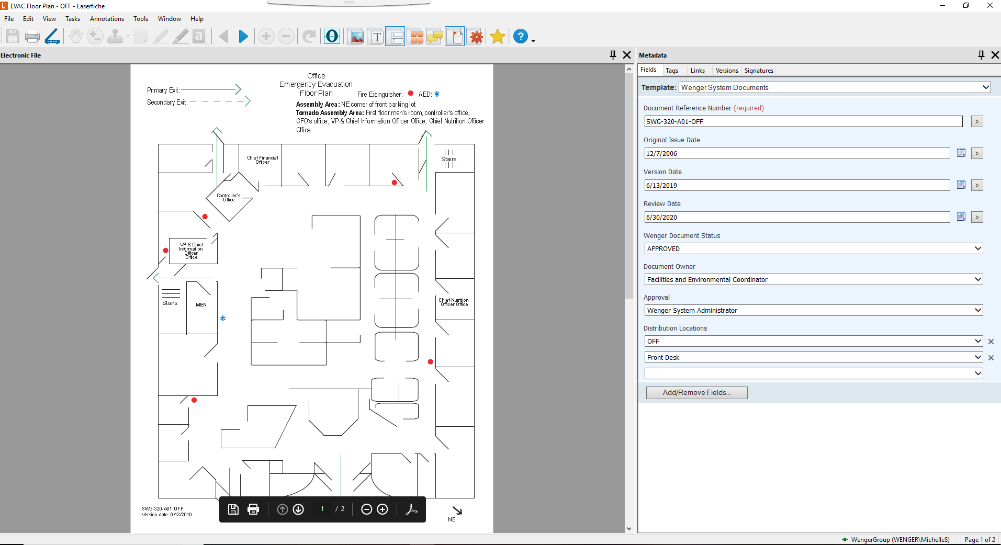

Same Admin user using Web Client

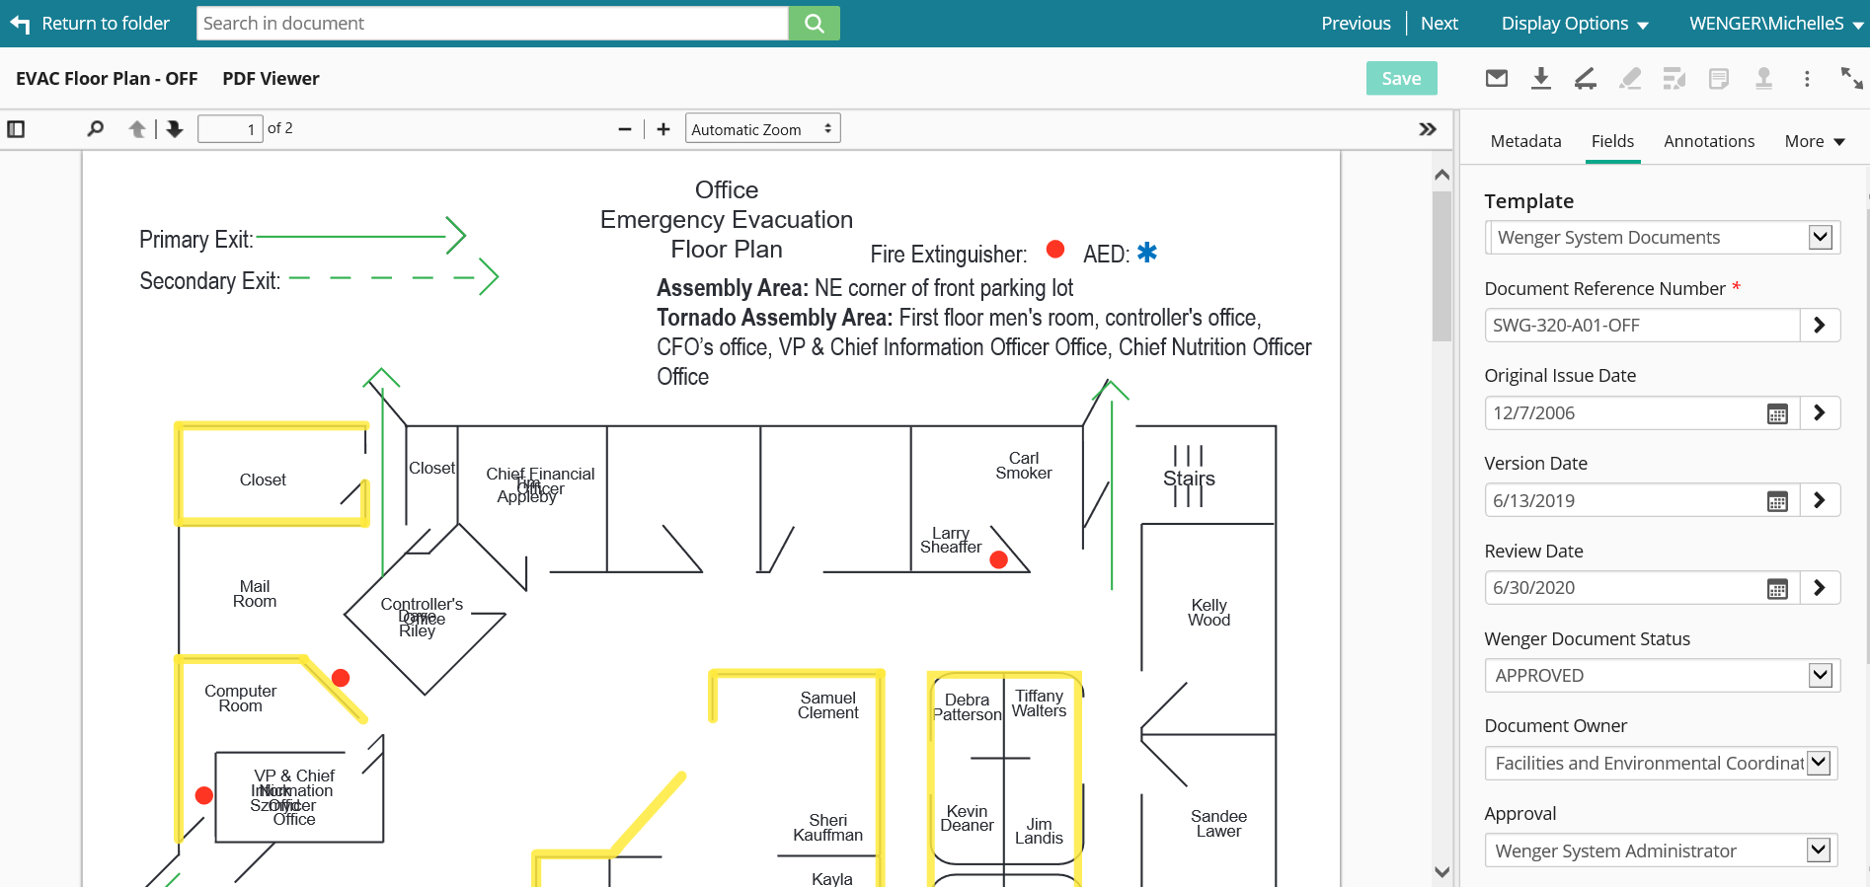

READ ONLY USER accessing SAME document:

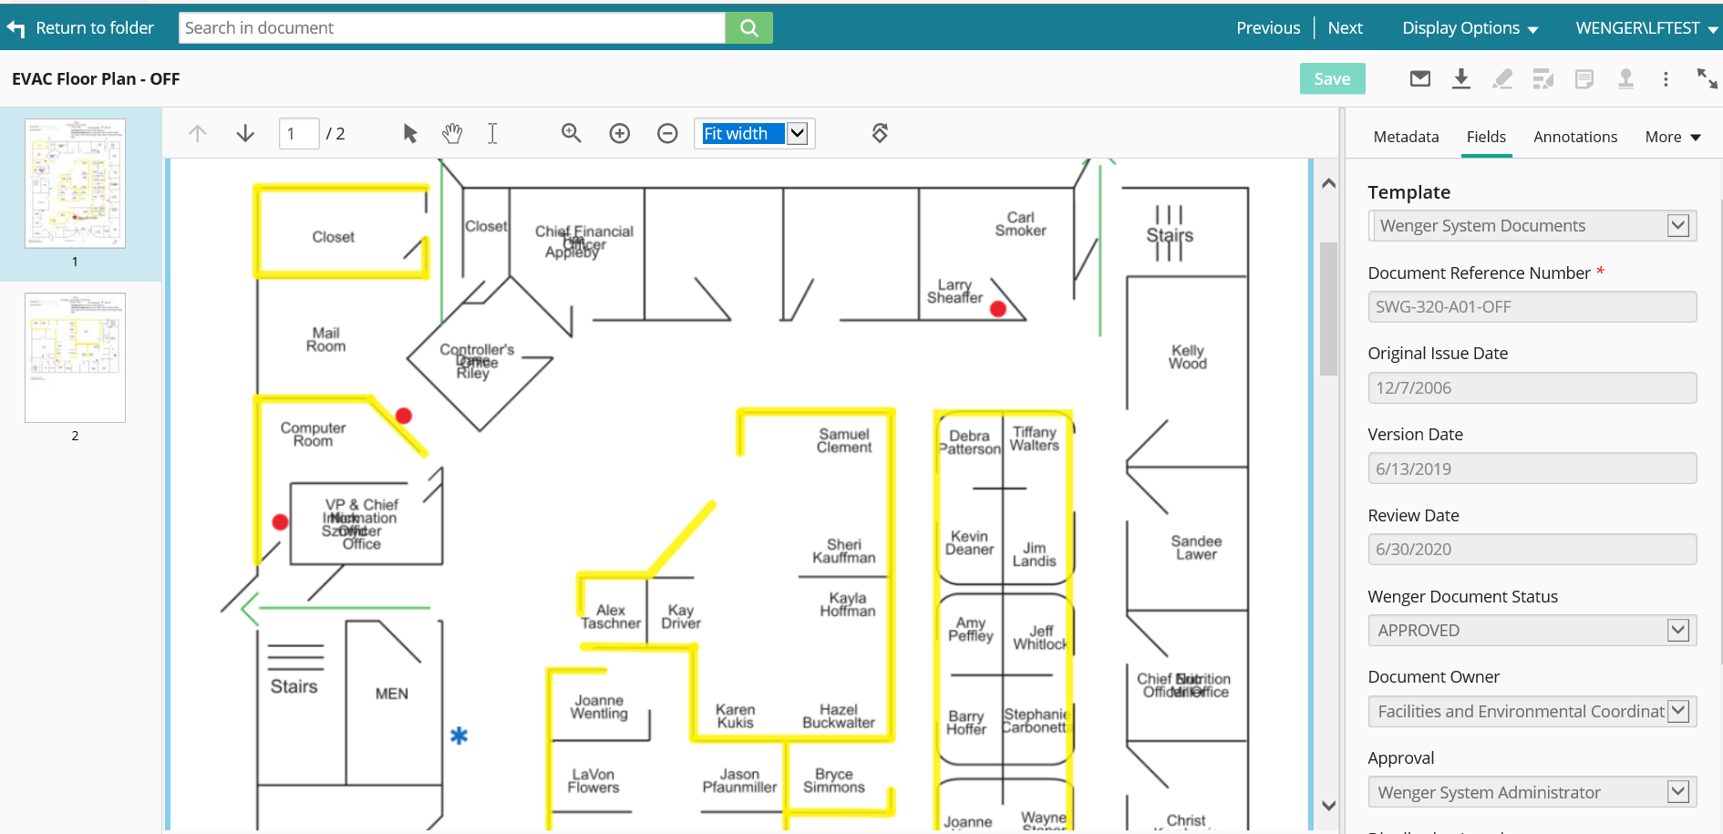

Web Client for both Admin and Read Only shows old layer of information on the PDF