We ran our Clerk Filing Workflow to file some ICRMP documents.

The “Move Entry to ICRMP folder” uses the following Destination:

\.Archives\CITY CLERK\CERTIFICATE OF INSURANCE\ICRMP\%(RetrieveFieldValuesGeneralTemplate_Date#"yyyy"#)

The year folder that is generated in the ICRMP Records Folder appears to be a regular folder () and not a Records Folder () .



However, when I right click on the folder () “Record Properties” is there as an option.

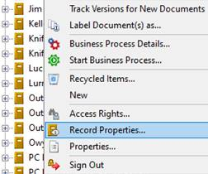

Click on it and the “Record Folder Properties” window is displayed with the  icon for the 2017 folder, and it appears retention can be applied to this folder.

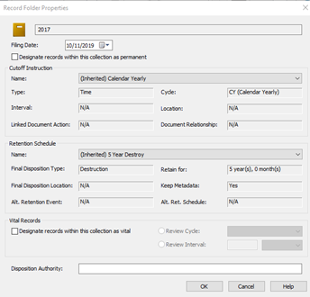

Are these “Record Folders” with a “regular” folder icon?

Any ideas on how we can get the “Record Folder”  to appear in the  instead of the ?