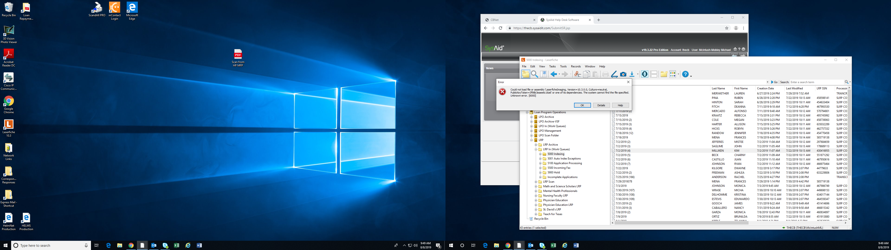

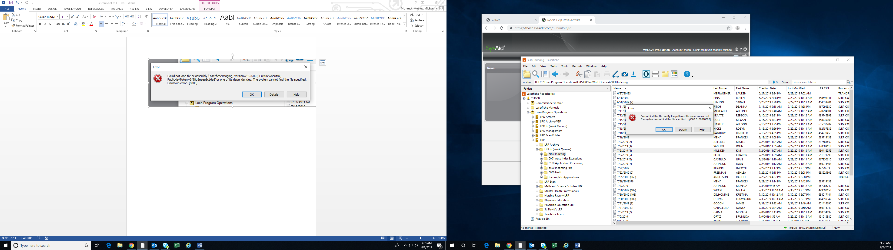

Error Code: 6000

Error Message: Cannot find this file. Verify the path and file name are correct.

The system cannot find the file specified. [6000:0x80070002] (The system cannot find the file specified. )

------------ Technical Details: ------------

LFSO:

Call Stack: (Exception)

SSPILogin

InternalDoLogin

LFSession::Login

CLFConnection::Create

Additional Details:

HRESULT: 0x80090322 (SSPILogin, LFSession.cpp:2048)

(LFSO/10.3.0.85)

LF.exe (10.3.1.479):

Call Stack: (Current)

CEmailSender::SendEmail

Additional Details:

Exception: 0x80070002 [6000] (Cannot find this file. Verify the path and file name are correct.) (CEmailSender::SendEmail at EmailSender.cpp:98)

Call History:

CLFClientAutomation::ExecuteAutomationCommand (GetWindowInfo)

GetRepositoryProperties

GetOptionString ([Settings]ExportEmailUseOutlookObjects)

CAttachedRepository::GetProfileValue

CLFClientAutomation::ExecuteAutomationCommand (GetInstanceInfo)

CLFClientAutomation::ExecuteAutomationCommand (GetWindows)

CLFClientAutomation::ExecuteAutomationCommand (GetWindowInfo)

GetRepositoryProperties