- Navigate to Laserfiche https://laserfiche.quiktrip.com/laserfiche/browse.aspx

- Check the box to the left of the item that you want to print.
  - 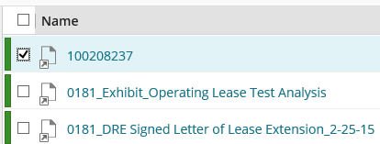

- Then select the “Download” button in the ribbon on the top right of the page.

- Next, select the “Download” button on the pop up. It should open in PDF reader.
  - 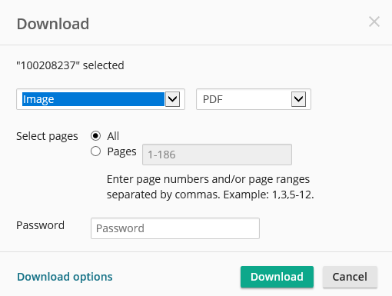
- Once it opens in PDF Reader, you can select the file tab and print. 