10.4 Web Client Send Document Link in Email

I choose to use my Outlook client

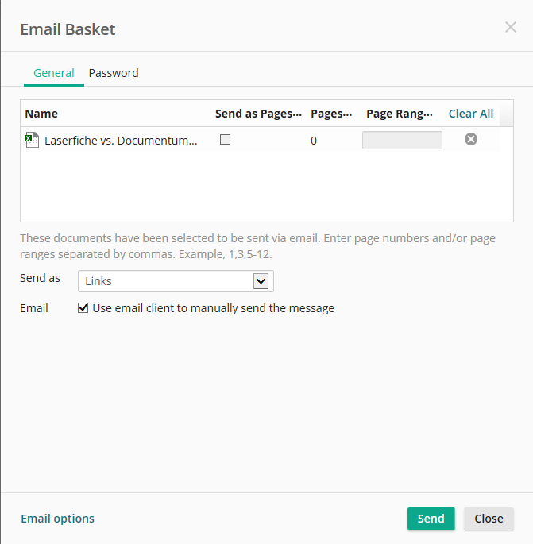

I click Open:



I send the email:

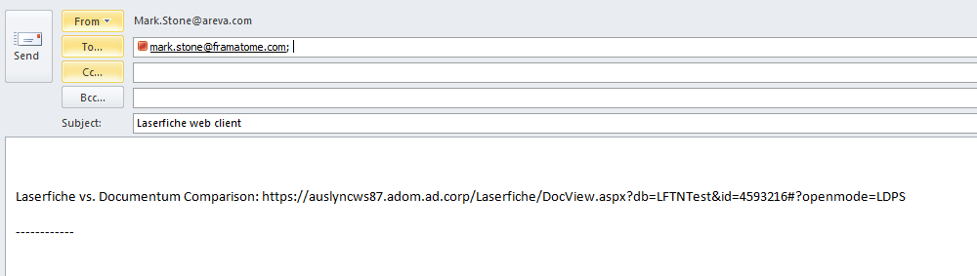

And I receive:

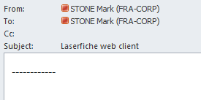

Found the cause/fix The email body does not seem to be formatted properly.

When I click in the body of the email and flip the “Format Text” to “HTML”, the link works fine.

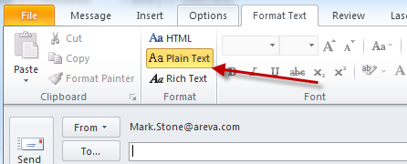

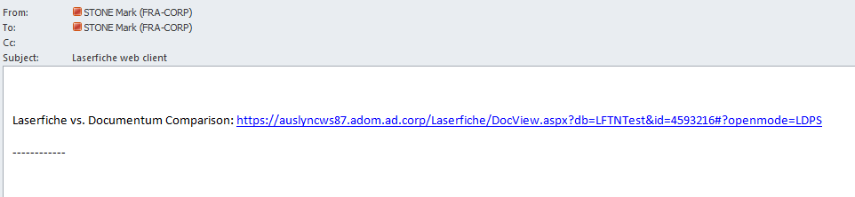

When I click in the body of the email and flip the “Format Text” to “HTML” and back to “Plain Text”, the link works fine.



