In web link under My weblink under browse options users can select the metadata they would like to see. **(Pic1)**. However, some of the metadata is only visible at the folder or content levels depending on template. Is there a way to display metadata fields visible for that specific folder or content? The browse options work great for the folder level **(Pic2)** however when you drill down to content leve**l there is** a lot of white space (**(Pic3)**. The user doesn’t realize they need to scroll over to see metadata.

**Pic1**

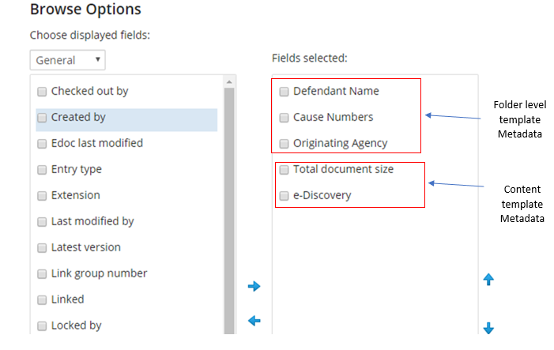

**Pic2**

Folder Template Metadata



**Pic3**

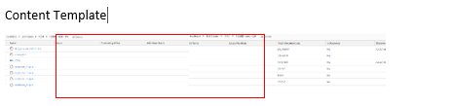

User do not see the metadata on the right, unless they know to keep scrolling to the right.