Here is a simple form with a user task.

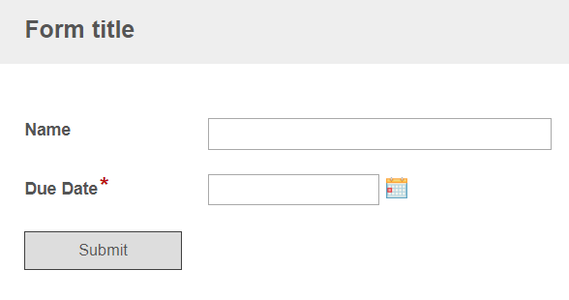

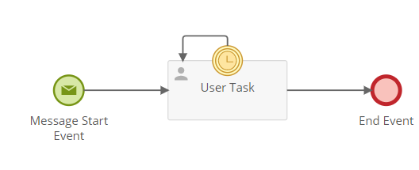

User task due date is based on the Due date variable on the form.

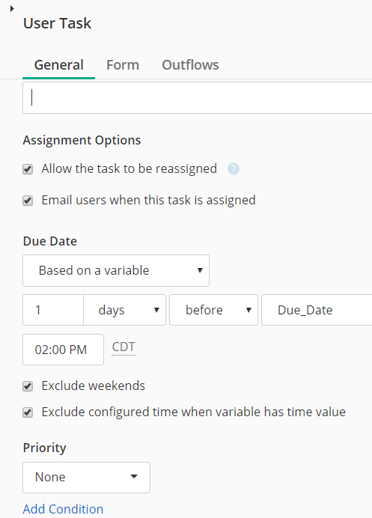

Time Catch event is based on Due Date variable.

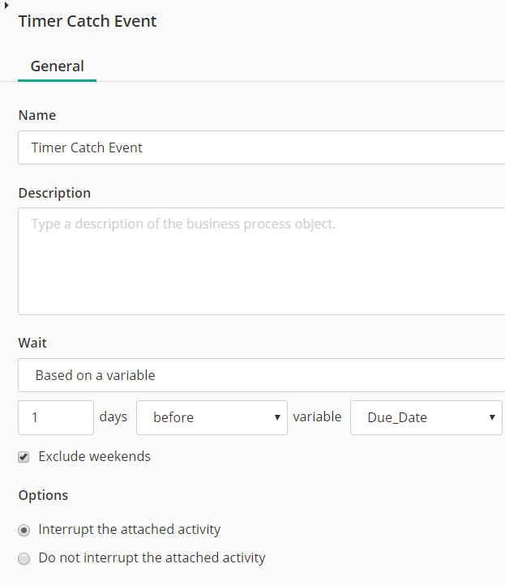

I submitted an instance with the Due Date as 6/14/2019. The user task got assigned immediately. Based on the above settings, I expected the reminder to happen on 6/13/2019. But in this case, it started sending the email notifications from 6/13/2019 12 AM, about 10 emails a minute. Had to stop the instance to stop the notifications.