Here is a test case. There are 2 pages on the form.

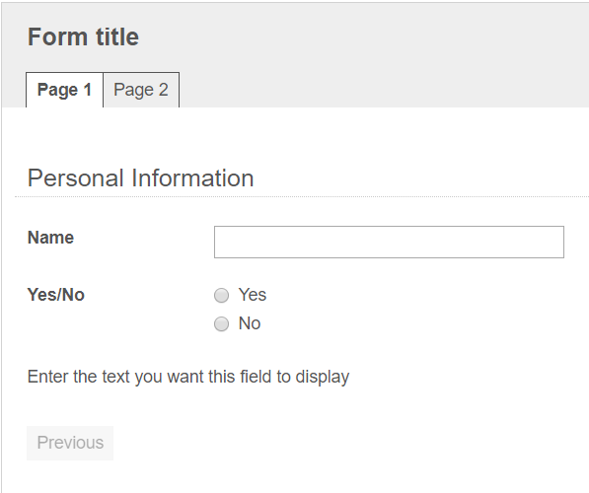

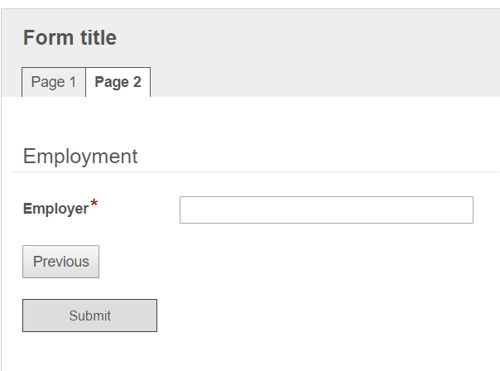

If the user selects ‘Yes’ then the user should be able to navigate to Page 2 and submit the form.

If the user selects ‘No’ then the user should be able to submit the form without filling any of the fields in in Page 2 including the required fields.

If I use the field rules as below

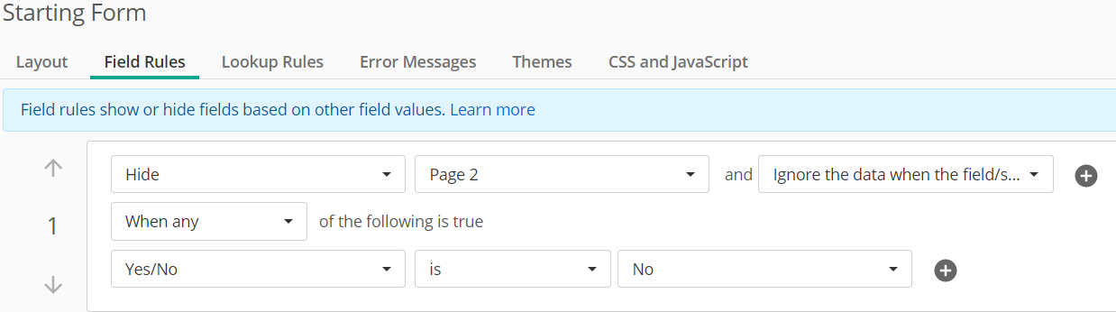

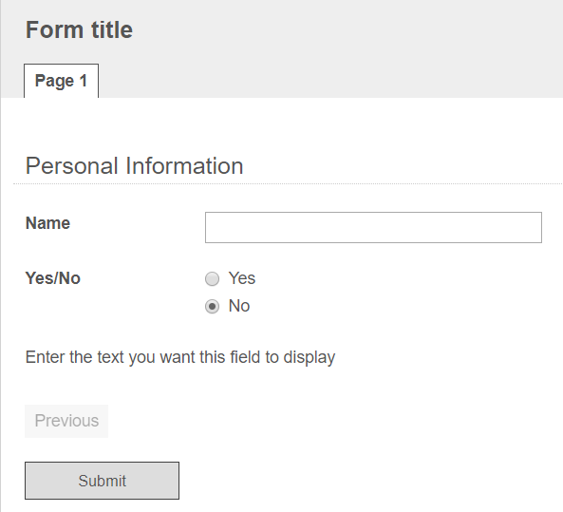

It throws an error as given below.

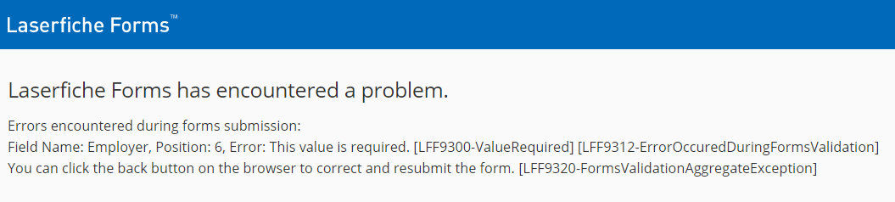

Above error is happening because there is a required field ‘Employer’ on Page 2.

I tried to hide the page using JavaScript too, even that doesn’t work. With JavaScript it does not allow you to Submit.

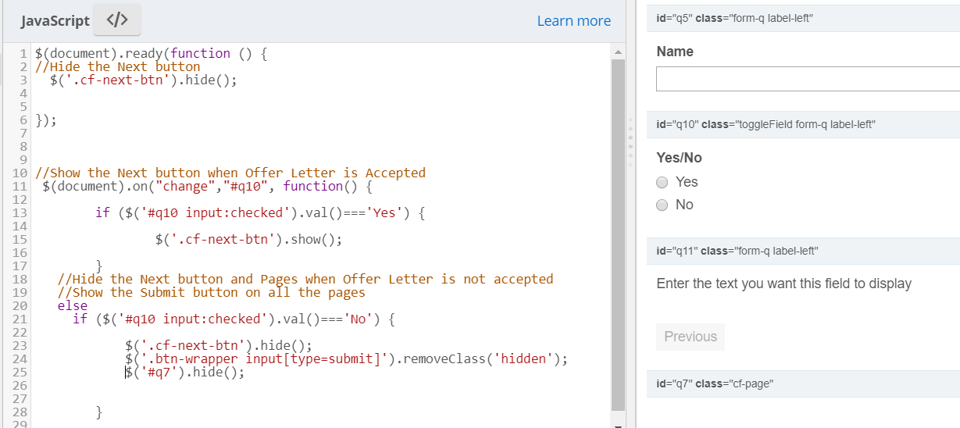

So finally I hid the section ‘Employer’ in Page 2 also in the Field rules and this works.

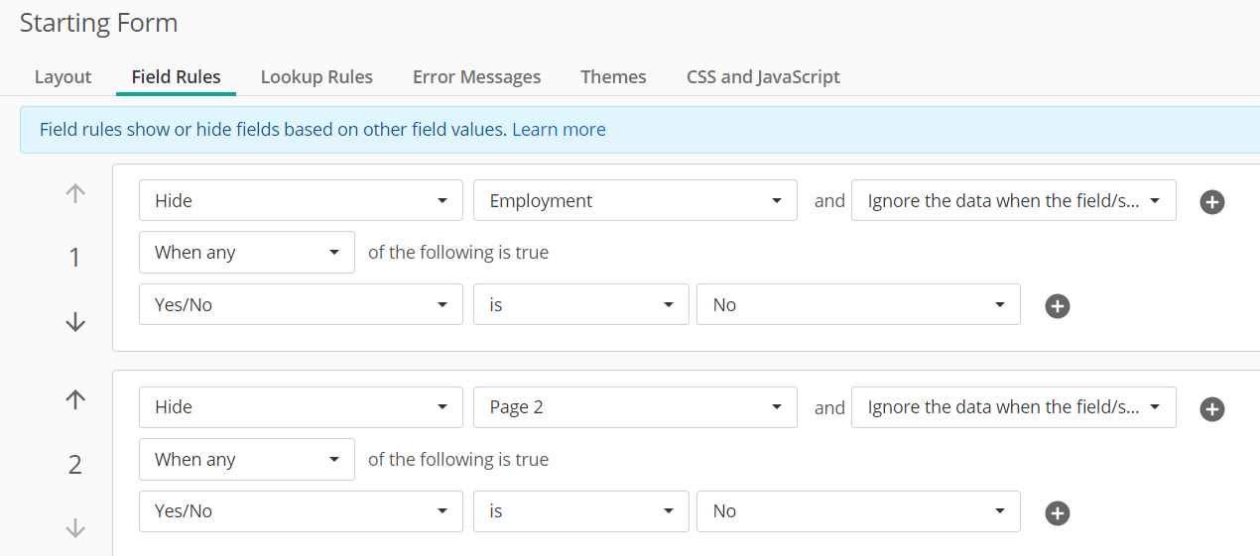

The original process has a long form and that was the reason it was separated into pages. It had 5 pages and each page had multiple sections. It was easier to hide the pages than hiding all the sections in each page. But since hiding the page was not working, I had to finally hide the sections.