LF + Azure what i have done so far…

We have 4 vms in azure (db, ds, lfapp + wf + web + forms, web + forms)

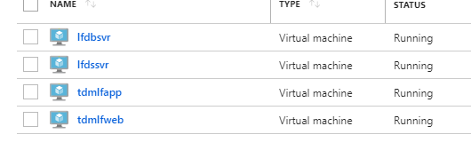
Two of them (app/web) are balanced.

We created an azure domain services account…

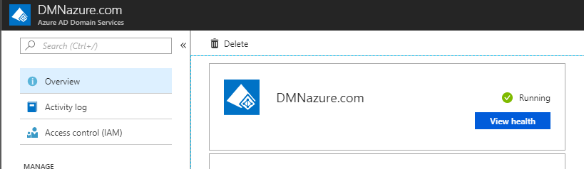
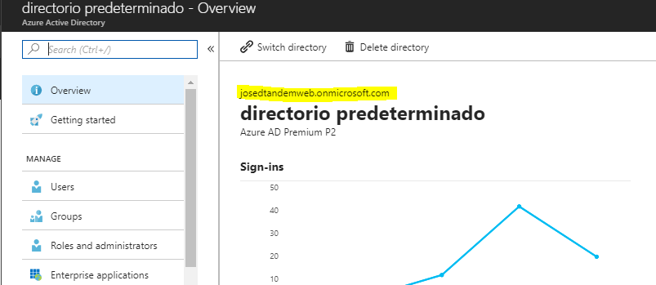

We have a local AD Server (dmnazure.local)
In that server we installed the azure synchronization app and after the configuration procedure the users are being replicated in our azure domain (dmnazure.com / josedtandemweb.onmicrosoft.com)

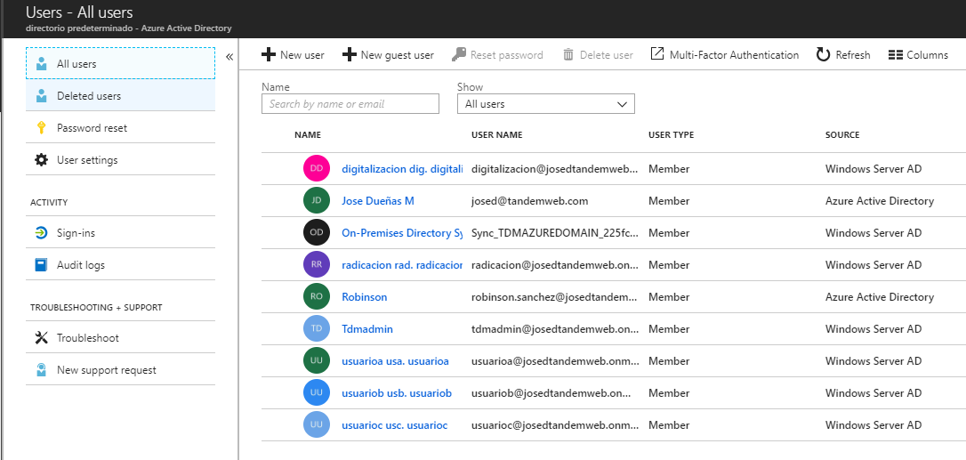

The azure virtual machines are in the domain dmnazure.com and lf products were installed successfully with no problem at all in any of them.

Then we needed to configure DS so the users accessing the products in balanced servers (lf web / forms) were authenticated against that server.

So, we configured an enterprise app in azure …

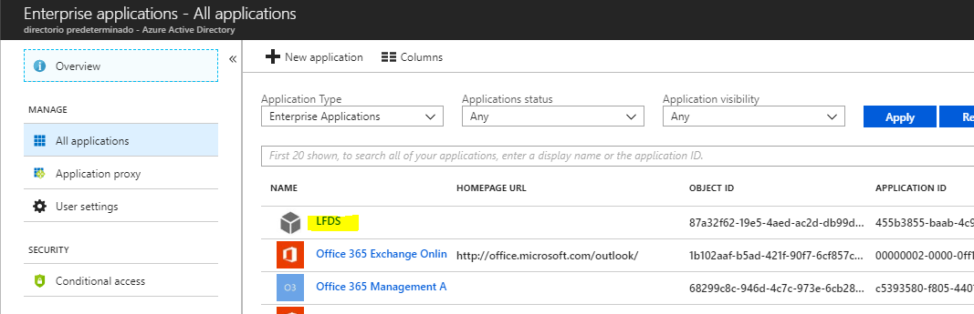

And for that app we configured SSO using SAML…

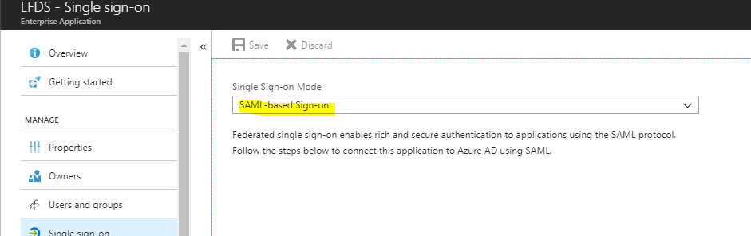

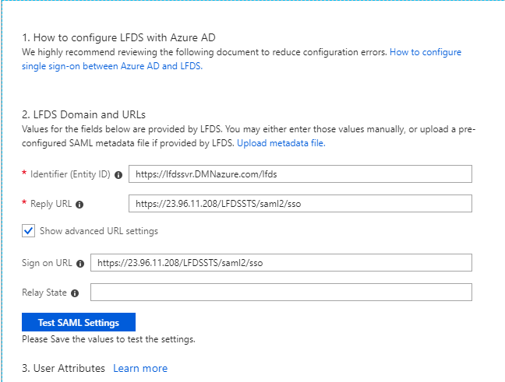
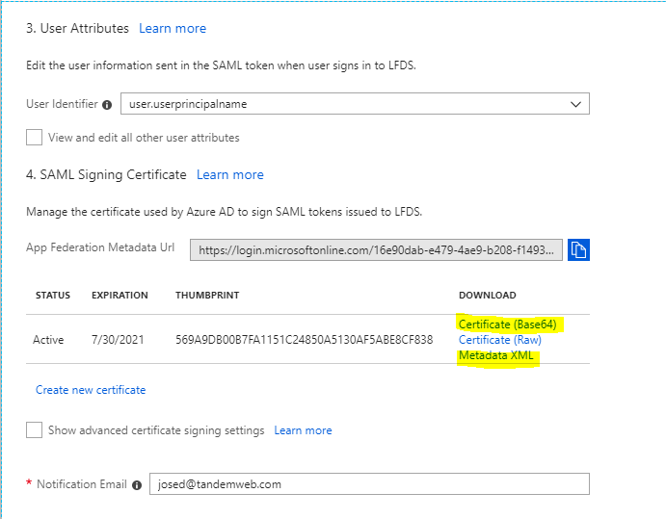

We used the metadata.xml file to configure provider in ds and registered the certificate in the server.
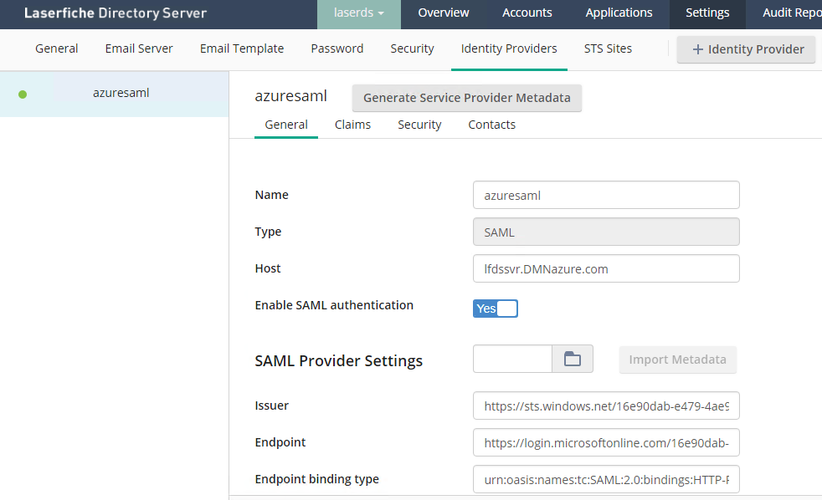

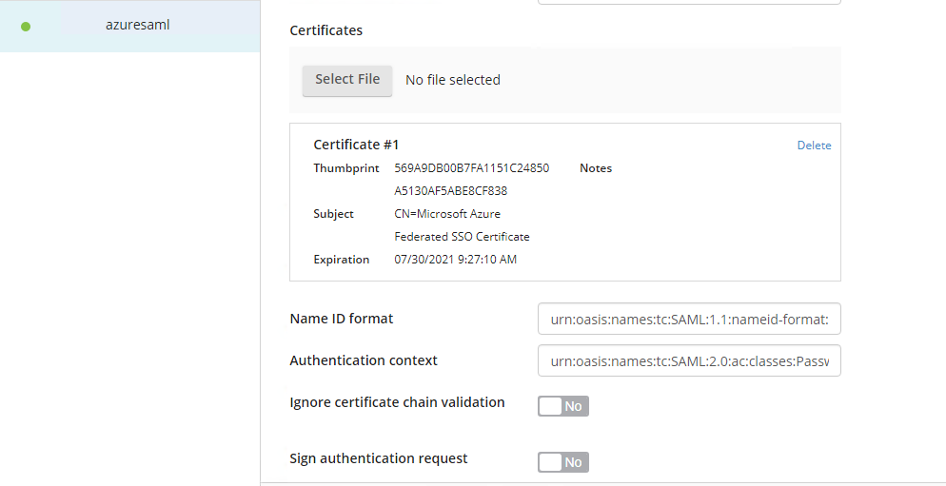

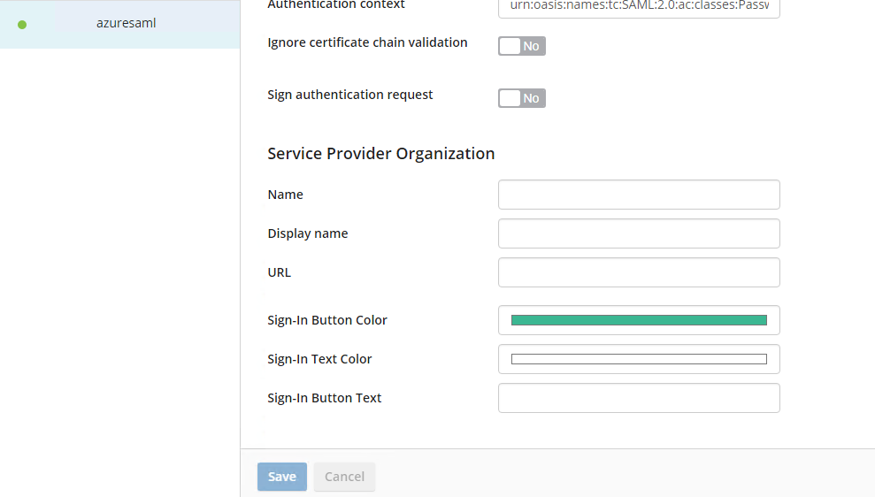

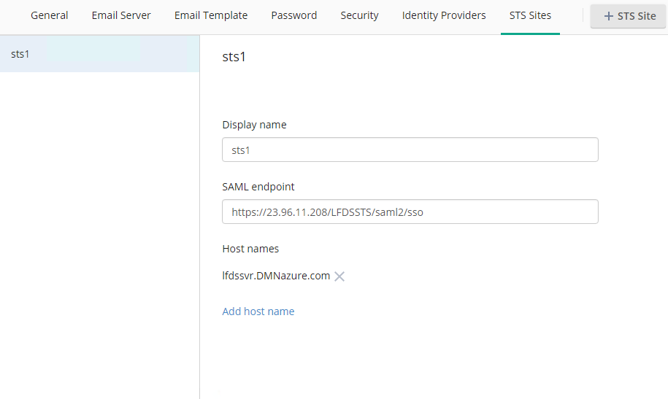

The users do not get synchronized automatically so you have to add them manually…

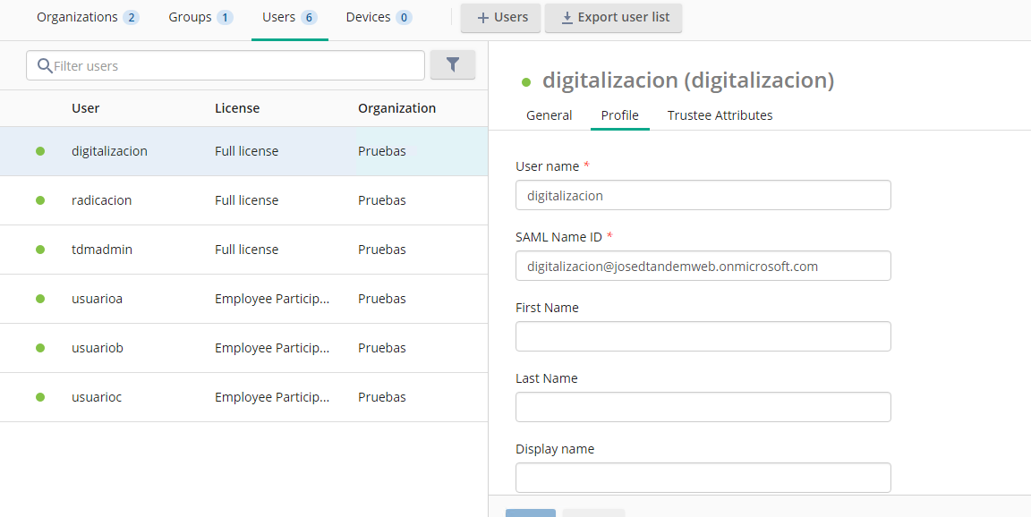

In LF I have the following configuration…

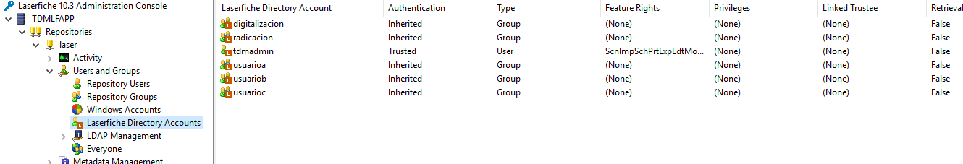

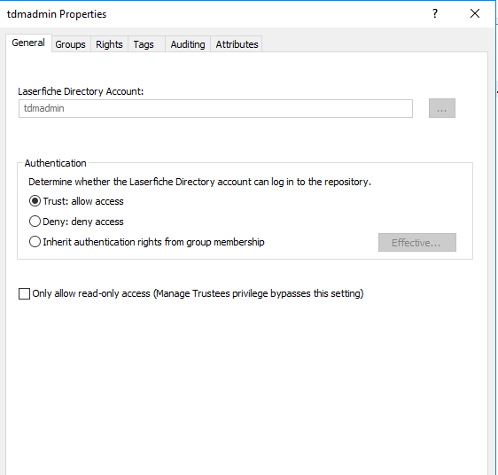

I have a local vm with win10 for testing … I must login using this user format ‘tdmadmin@josedtandemweb.onmicrosoft.com’.
I then access the balancer but it asks me for credentials…

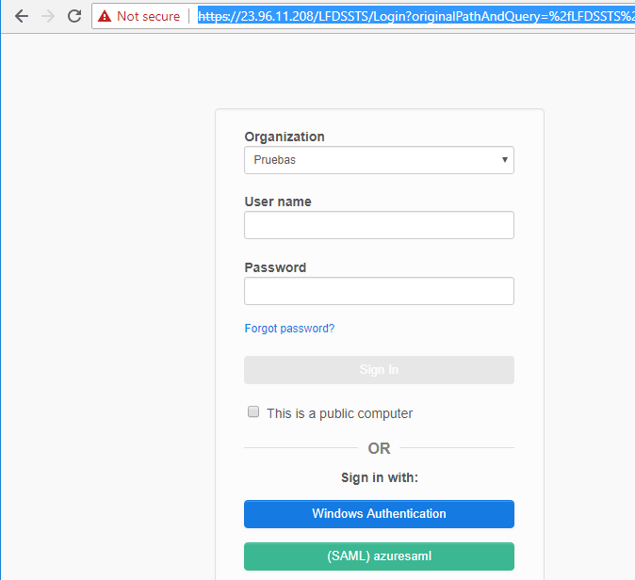

If I clic the SAML button ask me the Microsoft credentials…

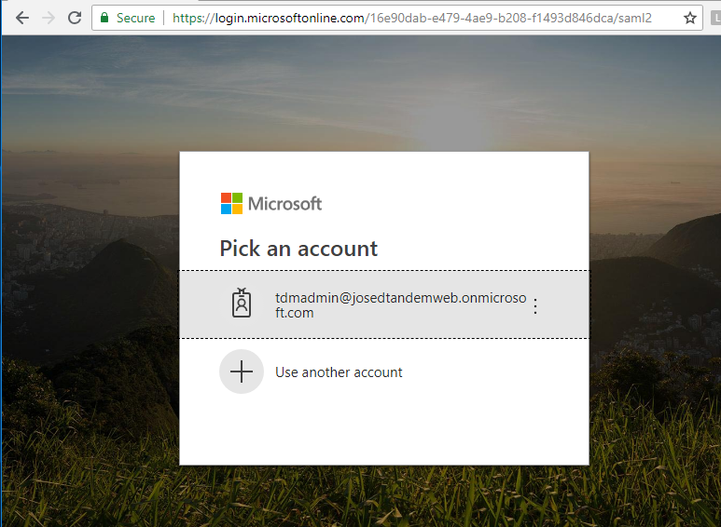
So I use the domain password and it works.

Hangs and never show the next page. So I stopped and repeat the procedure… lt shows me the credentials page again, then I clic SAML button and sends me to LF web client with the correct user…

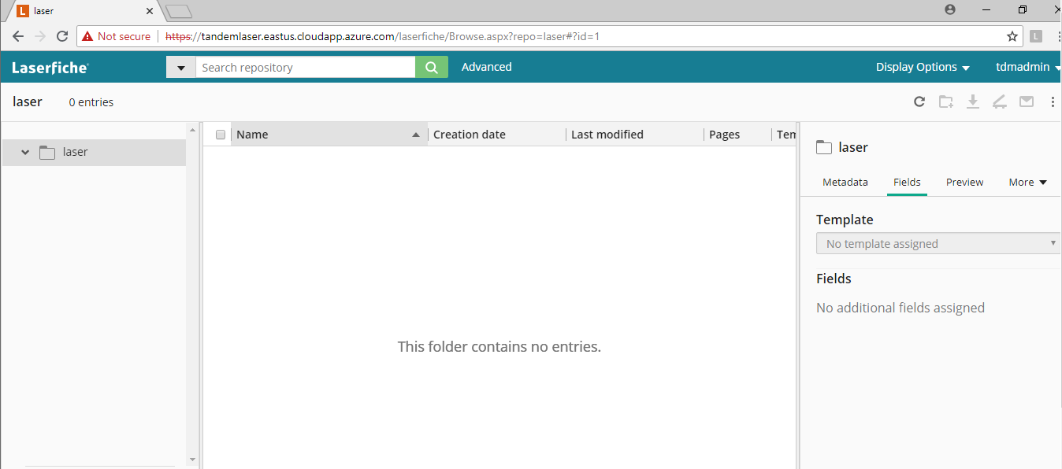
If I repeat the procedure always sends me to the web client correctly. Even if I close the browser.

If I try to access Win Client from that local vm I get access denied error…

