## 

## Design Requirements

### Importing Documents

EDIOnrequest to push Acknowledgement document to Laserfiche via a WebService~~.[Richard: For my understanding, using WebService in LF only transfer information through series of parameters but NOT a physical file, you can’t just replace import agent with Webservice for a physical file. If it require just Data ONLY (not a physical file), it may transfer data via web services but please confirm those series of data, such as AckNO, customer name, ect… with EDI]~~ Laserfiche will save the document in the repository as a PDF. This should remove the requirement to capture this document using Import Agent.

When an Order in EDIonrequest is ready for shipping, a trigger is to be sent the Laserfiche Workflow service which in turn, will be used to start a Forms Task for that item by generating the BOL.

Have the Customer enter the Acknowledgement number, user Workflow WebService to retrieve other data fields from EDIonrequest

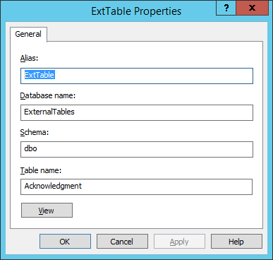

### Data Availability

The EDIonrequest solution is supported by Unimatrixsolutions and have discussed ability to access the SQL DB to make queries via web services. Some of the workflows could use this lookup capabilities to pull customer information for Metadata or populate Task Forms to remove the requirement to enter data manually.

### User Interaction

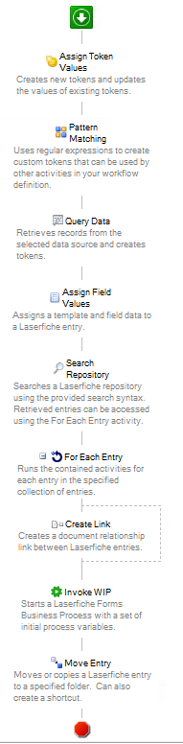**Process Start**

* ~~Acknowledgement Generated by Syspro and save into folder monitor by Import Agent~~ Acknowledgement generated by EDIonrequest and sent to LF Workflow Web Services for ingestion into LF Repository. The file can be saved using the Acknowledgement Number and Metadata populated [ie. Filename: first 6 digits is ack no] ackno is unique? **(Yes, Ackno is Unique)**
* ManuNewAck Workflow kicks off (see to right)

This Workflow may change based on what is provided from WebService. Linking to documents already in system (ie:PO) still required

* - ~~Pulls Acknowledgement number from page~~ [filename is ack no?, yes, first 6 digital of filename is ack no] **(Yes, currently 6 digits, may expand to 7 when they reach 999999, it would be all of the numbers up to the Acknowledgement.tif (ask for sample output from client to validate)**
* - Looks up customer info from DB (clarify the db and table name)

**~~This will needed to be provided by Customer IT (ie: Pheonix). Make request to customer for this information. Update: Pheonix will provide Stored Procedures for Lookups, we need to define what information is required.~~**

**This could be collected from WebServices Interaction above**

* - Assigns Metadata, ackno, customer name and invoice
* - Finds Matching PO in system and Links if there is one
* ~~- Kicks off Forms “Manufacturer WIP Task”~~
* - Moves Shortcut of Acknowledgement to Customer Folder

This workflow to be reviewed and updated based on changes to flow of document using Web Services.