So with this most recent example. I entered a custom description and the form got saved in this format (Left picture). Instead of the intended way (right picture).
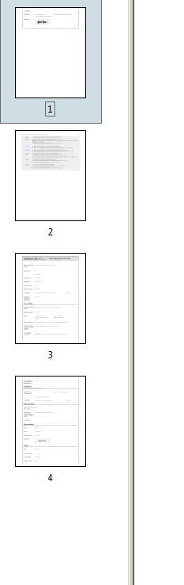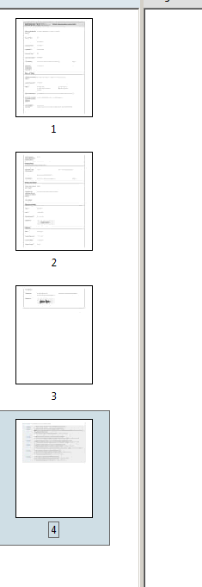
In this picture, we have the workflow for the ToT being ran after it was updated.

