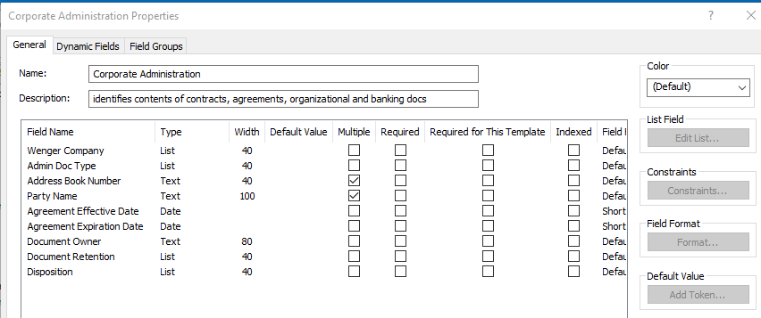

Field setup for dynamic field

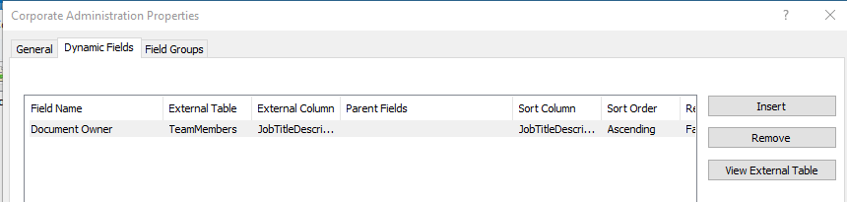

Preview of template showing lookup which populates drop down

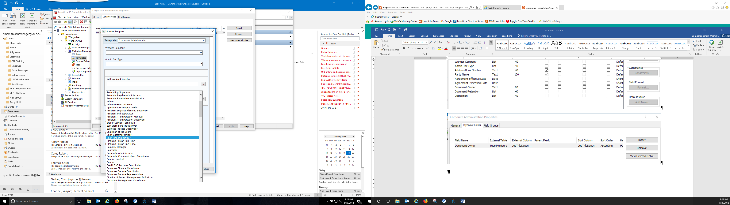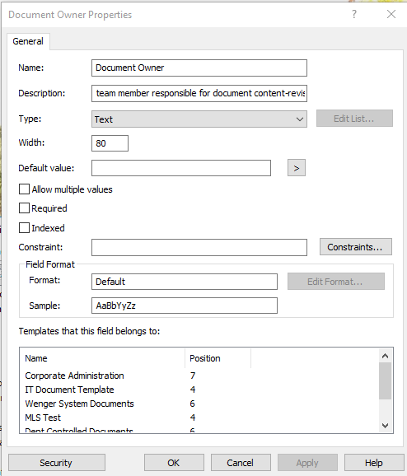

Field properties showing field used in multiple templates