1. Generate Report – This produces a report from the Search Results list. This list will be in work order number (or Mill) based on your sort above. Once exported, the report can be sorted differently.
2. Choose the ellipses beneath your user name to open the More Options menu

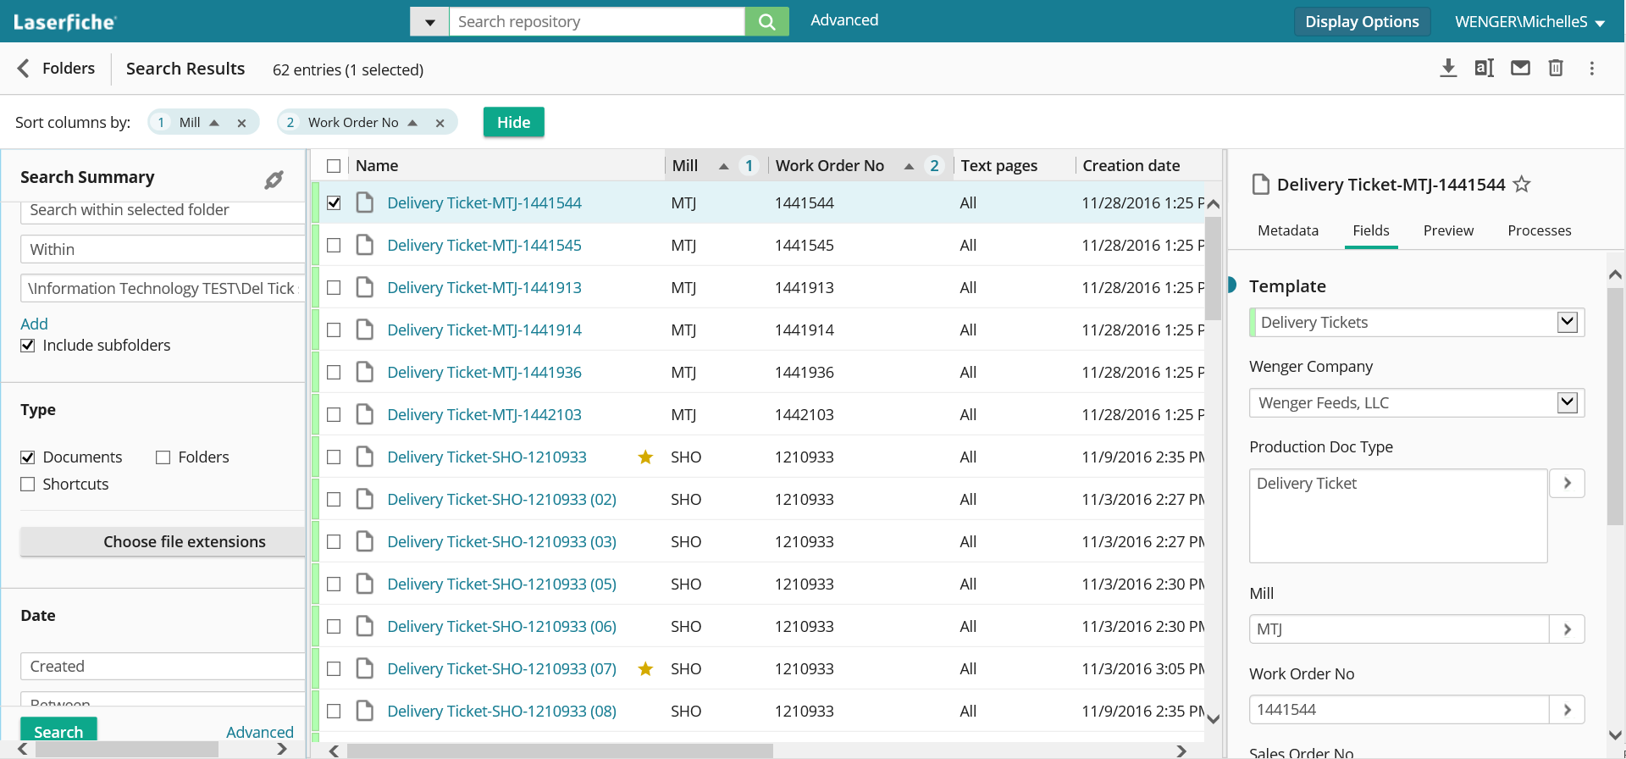

1. Choose **Generate Report** from that menu
2. Choose **Metadata Report** from the dialog box

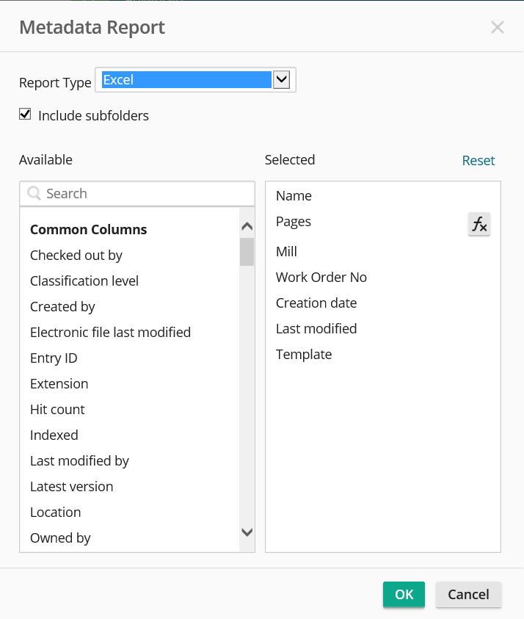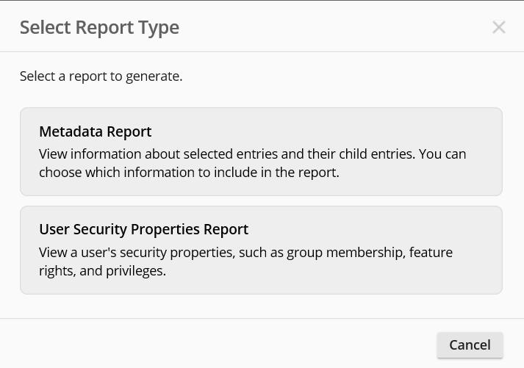

1. Then build the report by adding fields to it from the **Column Builder**. Click OK
2. Choose **Save** from the ‘Do you want to open or save’ dialog box



1. Choose **Open Folder** from the ‘Download Completed’ dialog box



1. Once folder opens, go to **MyReport** and double click to open

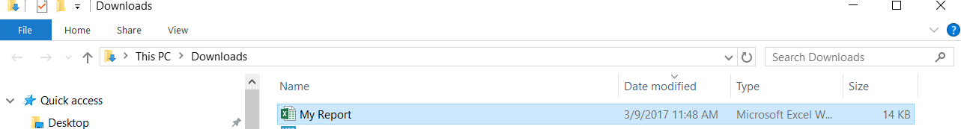

Choose **Save As** in Excel and choose the folder where the report will be saved and name the report