First half is done.

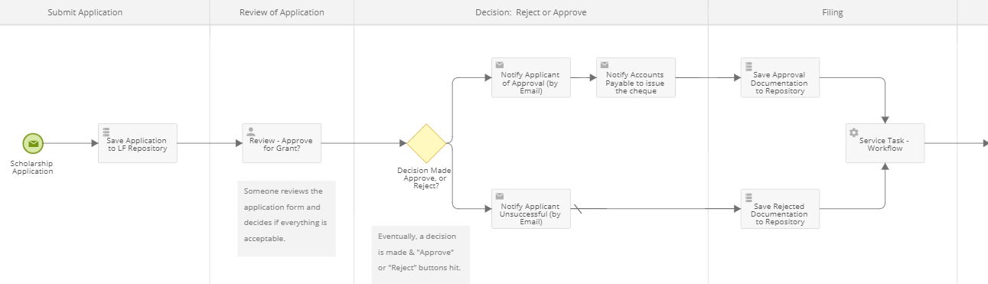

Second half – need to figure out how it will re-start when the Follow Up form is submitted:

