# Web Access Configuration Issue

I am trying to configure a system for the customer to allow some uses to approve a requisition in workflow using Web Access and be authenticated with their Windows credentials.

I am getting the error below when I try to access the system with an account that his in the Admin group.

This user can access the system without issue if they are using the client account.

Below are screenshots of the configuration screens.

1. Screenshot to show that the user can access the repository using Web Access however the user soon gets an error message and is unable to access any directories or documents.

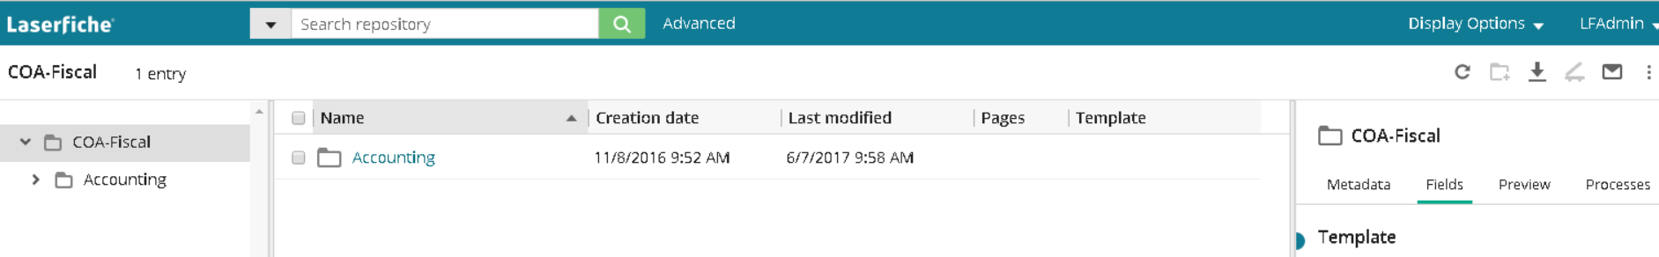

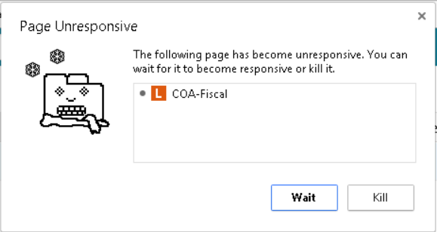

1. 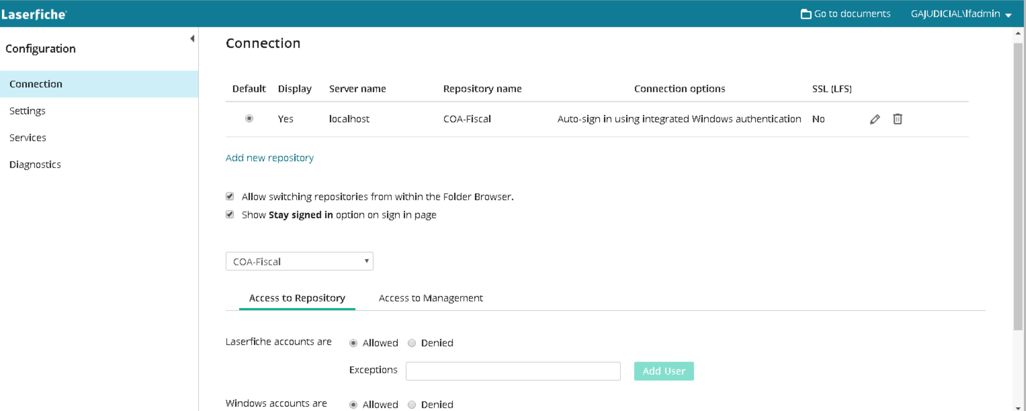
2. 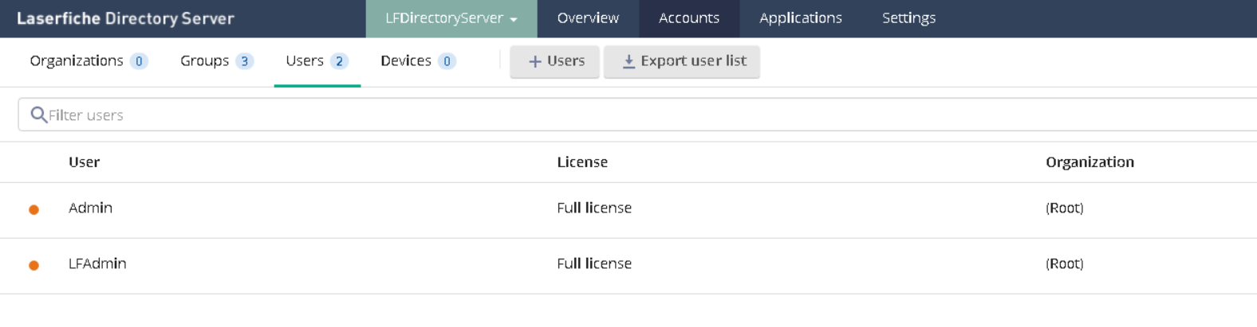
3. 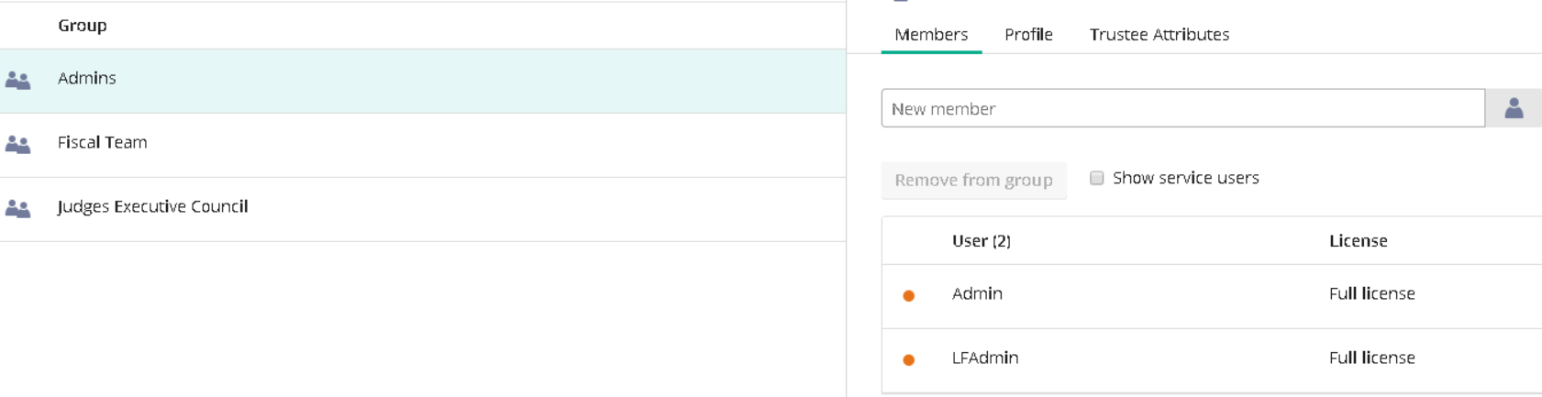
4. 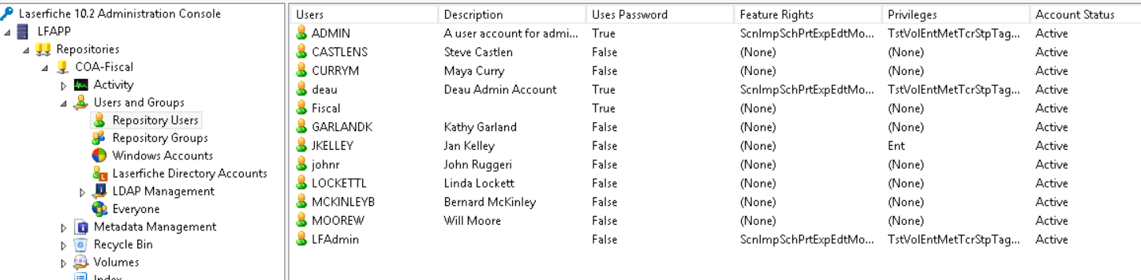
5. 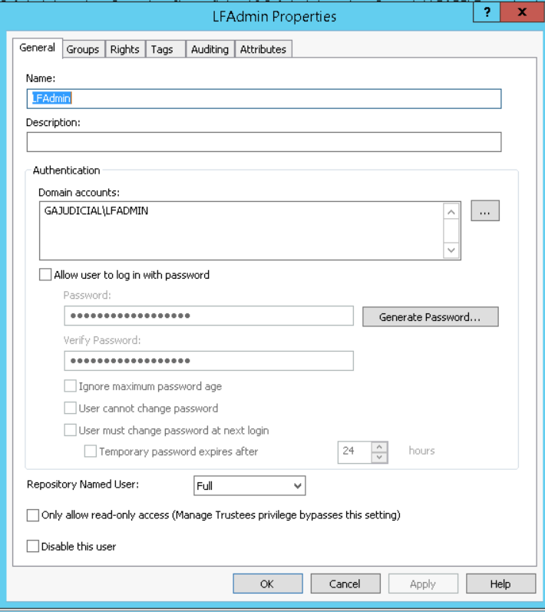
6. 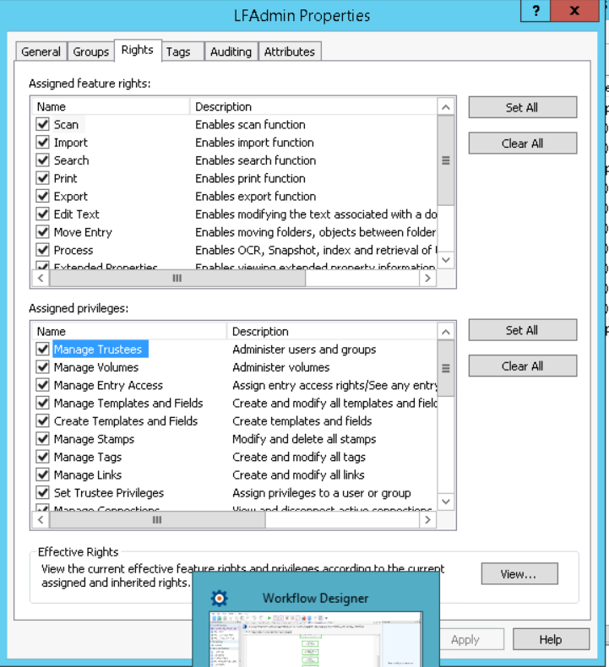All rights and privileges are set for both this user and the Admin group.
7. 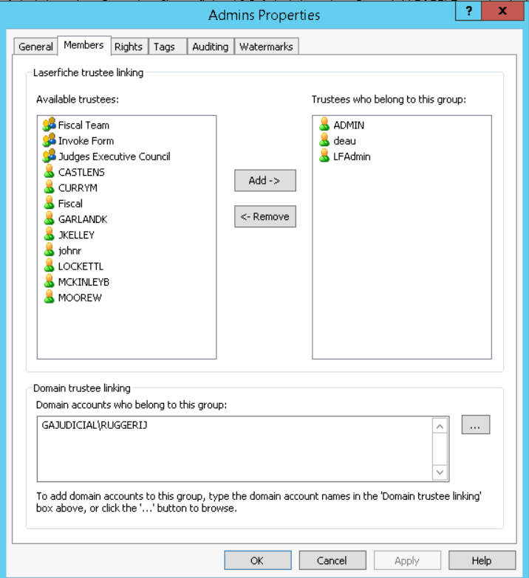 9. 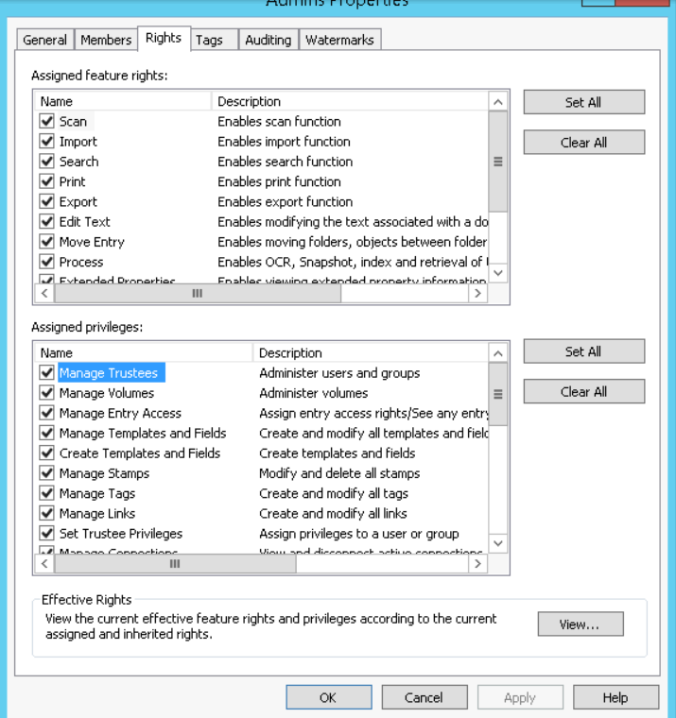
8. 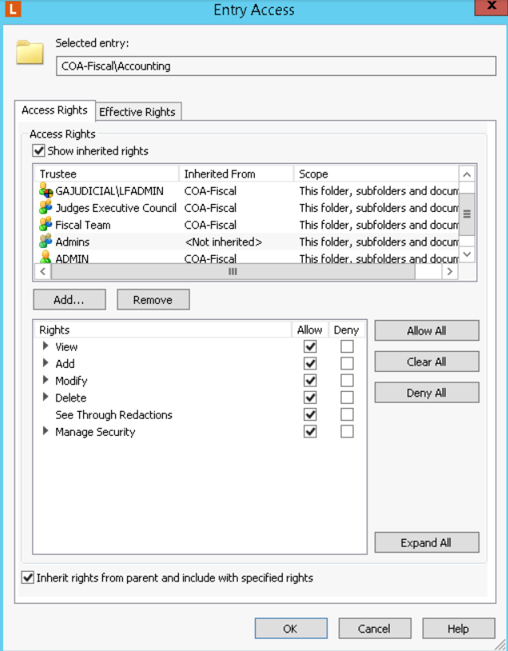 10. 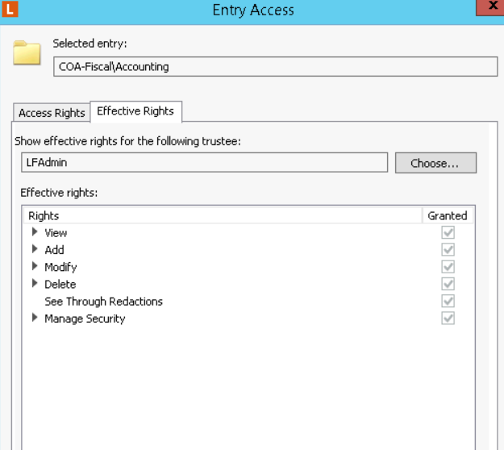
9. 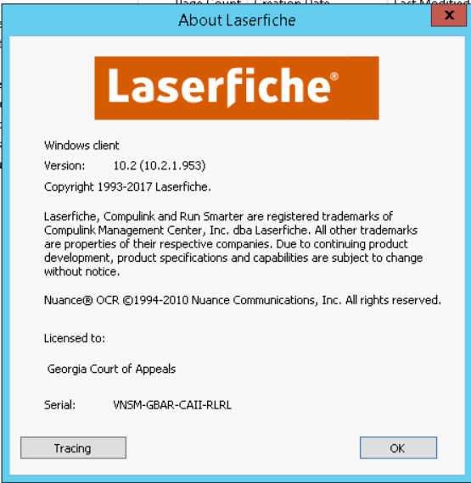 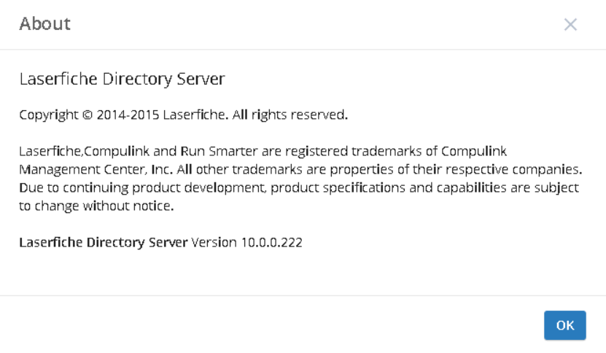
10. 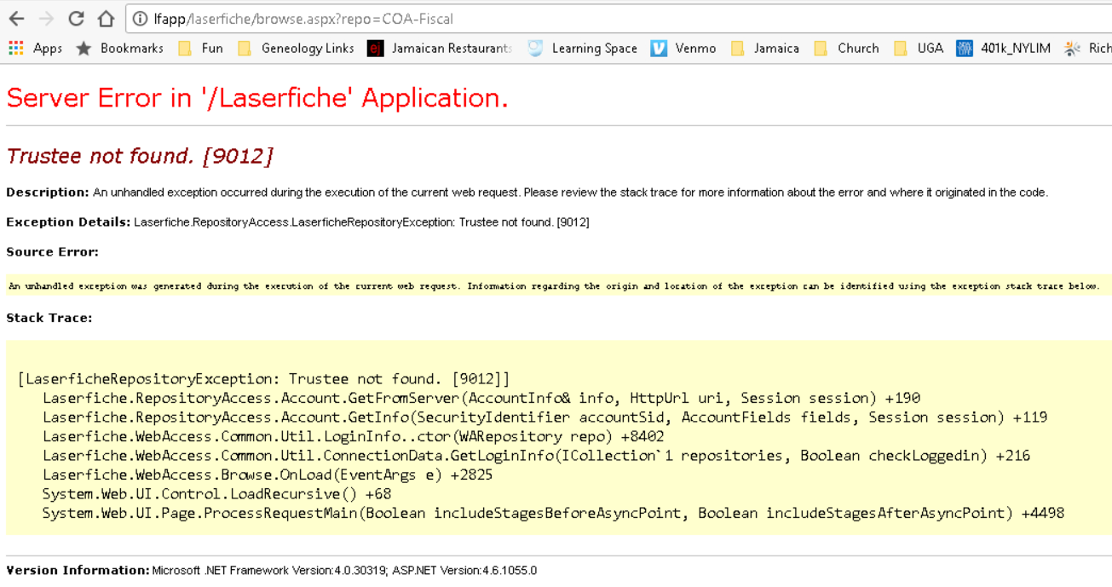
11. 