I want to hide of show the “Spouse / Civil Union Partner Information” or “Dependent Information” sections of my form based on what a user selected in the “Medical / Vision Coverage” drop down field above:

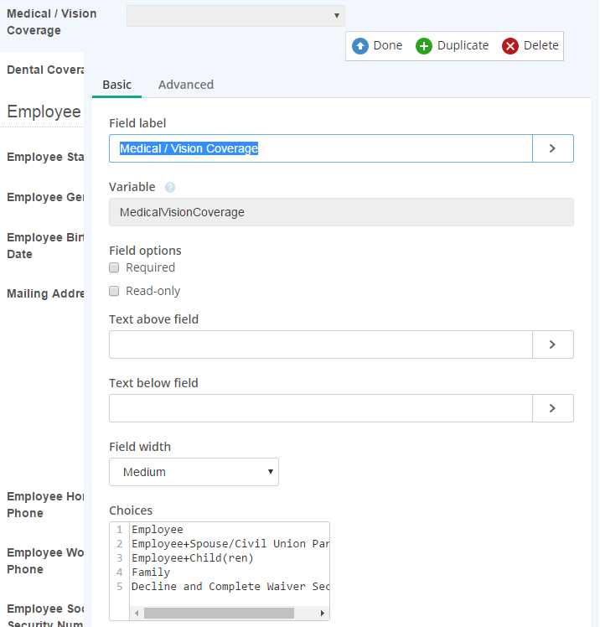

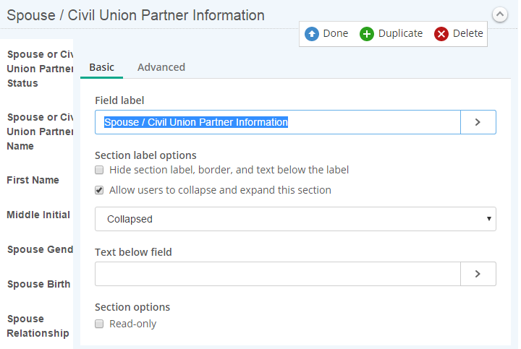

I can’t select a section from the look up rules – only the individual fields in the section:

