In red, the columns in the document that I´ve mentioned on the question where the Omnipage OCR Zones are defined.

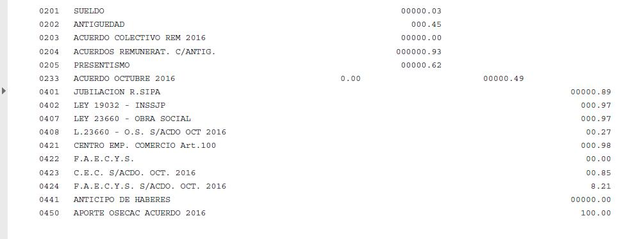

And this is the resulting pdf where the line order of data is not respected.

