From forms help:

<https://www.laserfiche.com/support/webhelp/Laserfiche/10/en-US/administration/#search-Regular>

This just spins and doesn’t yield any responses to search criteria word ‘Regular’

From Web Client help:

<https://www.laserfiche.com/support/webhelp/Laserfiche/10/en-US/userguide/#search-Regular>

This yields 34 responses from search criteria word ‘Regular’

Direct from LF Support Site

Current Online Laserfiche Product Help Files:

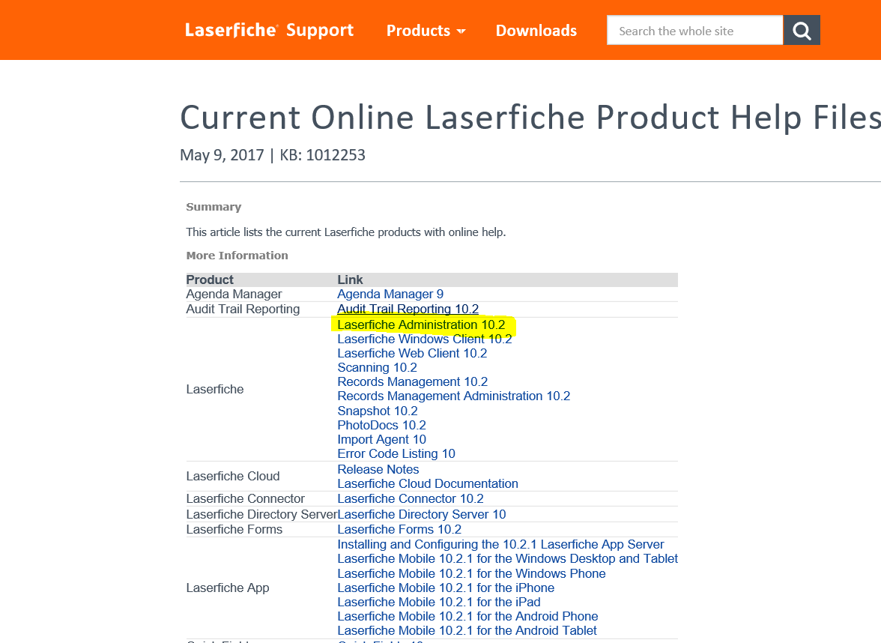

<https://www.laserfiche.com/support/webhelp/Laserfiche/10/en-US/administration/#../Subsystems/LFAdmin/Content/Laserfiche_Help_Center_rev.htm>

This just spins and doesn’t yield any responses to search criteria word ‘Regular’

The following links from the support site also spin and do not provide any response to search criteria word ‘Regular’:

LFDS

<https://www.laserfiche.com/support/webhelp/Laserfiche/10/en-US/administration/#../Subsystems/LFDS/Content/Welcome.htm>

Discussions

<https://www.laserfiche.com/support/webhelp/Laserfiche/10/en-US/administration/#../Subsystems/LFDS/Content/Welcome.htm>