Hiding Current Access if not checked for Removal
Wednesday, May 03, 2017
10:18 AM

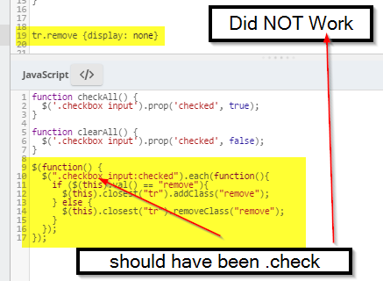

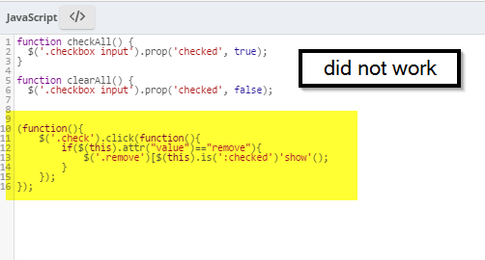

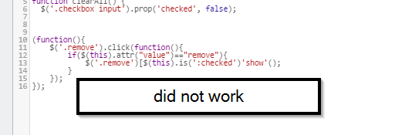

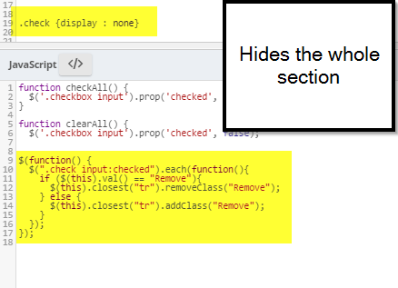

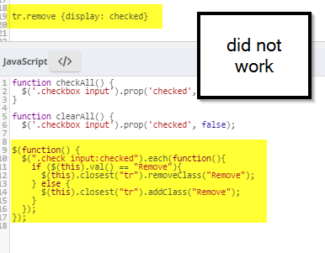

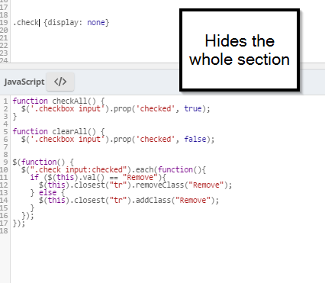

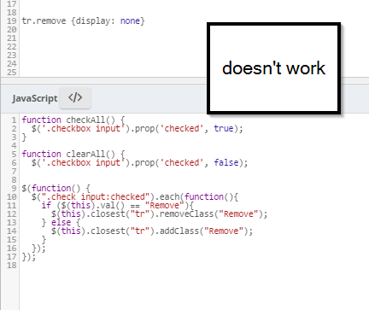

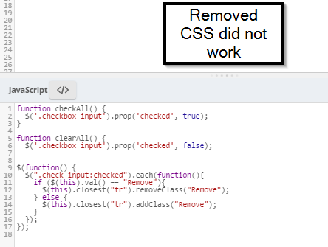

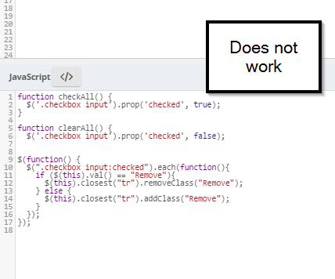

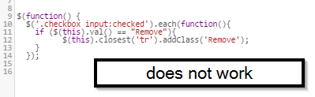

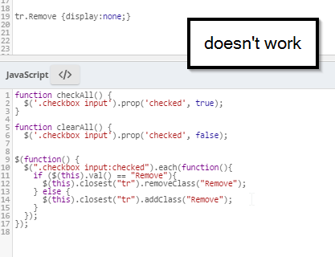

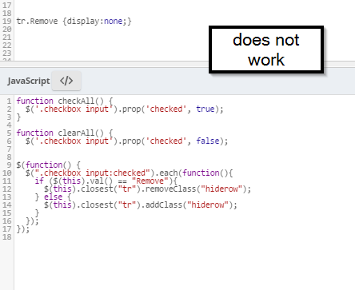

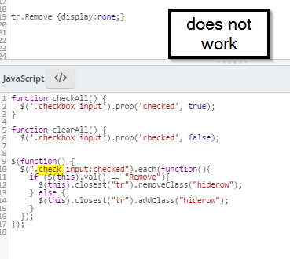

Changed all the fields in the table - no more "read only" fields - testing last code again…
Did not work. Changing .check to .checkbox in the table and script and "hiderow" to "Remove"… does not work
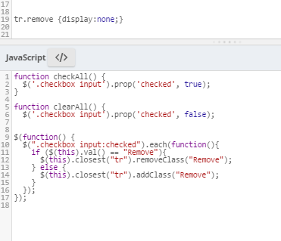

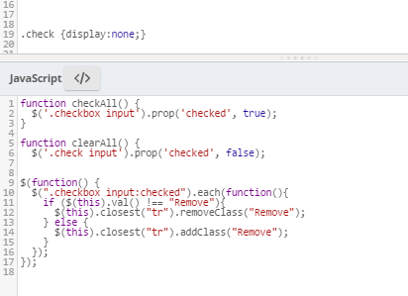

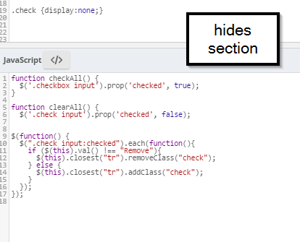

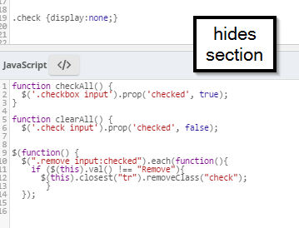

Cleared out all CSS classes and changed to just do the java that was listed in LF Answers
$(function() {
$(".checkbox input:checked").each(function(){
if ($(this).val() == "Remove"){
$(this).closest("tr").show();
} else {
$(this).closest("tr").hide();
}
});
});

Added CSS back in (change the table's CSS Class to access_table)
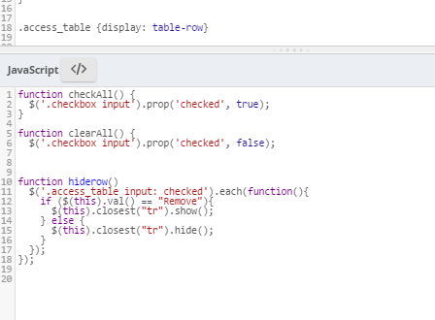
Did not work

